MUFG Solution Architecture Document  
Digital Banking

Bottomline Technologies, Inc.



|  |  |  |  |  |  |
| --- | --- | --- | --- | --- | --- |
| Date: | September 30, 2019 | Version: | V2.1 | Author: | Bottomline Technologies |

Copyright © 2019 by Bottomline Technologies

All Rights Reserved, Printed in the U.S.A.

Confidential, Unpublished

Bottomline Technologies Controlled Distribution

Property of Bottomline Technologies

Contents

Part 1. Introduction 5

1.1. Purpose 5

1.2. Document Scope 5

1.3. Target Audience 5

1.4. Reviewers 6

1.5. Approvers (Sign Off) 6

1.6. Document History 7

1.7. Document References 7

1.8. Risks and Issues 8

1.9. Glossary of Terms 9

Part 2. Solution Architecture Overview 10

2.1. Inventory of Systems Integrations 10

2.2. Networking 14

Part 3. System Integrations 16

3.1. File-Based Interfaces 16

3.1.1. ACH Payment Instructions to the Back-Office 17

3.1.2. Reference Data Loads 19

3.1.3. Prior-Day and Current Day BAI Loads 20

3.1.3.1. Prior Day Bank DDA to CMS 21

3.1.3.2. Prior Day Branch OVS 22

3.1.3.3. Prior Day Branch Multi-Bank Reporting 23

3.1.3.4. Current Day Bank DDA to CMS 24

3.1.3.5. Current Day Branch OVS 25

3.1.4. Loan Balances and Transactions (P3) 26

3.1.4.1. LIBOR Rates Feed 26

3.1.4.2. Loan 1098 Tax Form Reporting 27

3.1.5. Lockbox Reporting 28

3.1.6. Legacy Reporting 28

3.1.7. Check Issuance Extract (P3) 30

3.1.8. Positive Pay Exception Loader (P3) 31

3.1.9. Positive Pay Decision Extractor (P3) 32

3.1.10. Reverse Positive Pay Exception Loader (P3) 33

3.1.11. Reverse Positive Pay Decision Extractor (P3) 34

3.1.12. Billing Extract 35

3.1.13. Audit and Customer/User Detail Extract 36

3.1.14. Holiday Reference Data Load 37

3.1.15. ACH Positive Pay Exception Loader (Not in Scope) 38

3.1.16. ACH Positive Pay Decision Extractor (Not in Scope) 38

3.2. Real-Time Synchronous Interfaces 39

3.2.1. Error Messages and Host Response Code Handling 39

3.2.2. Check Inquiry 40

3.2.3. Check Inquiry - Stopped Checks (not in scope – handled by check inquiry) 41

3.2.4. Check Inquiry - Paid Items (not in scope – handled by check inquiry) 41

3.2.5. Cancel Stop Check -Single Item 42

3.2.6. Stop Check (Range or Single) 43

3.2.7. Deposit Ticket Item List Retrieval (P3??) 44

3.2.8. Real-Time Account Balance Retrieval (Not in Scope) 45

3.2.9. Real-Time Account Transaction Retrieval (Not in Scope) 45

3.2.10. Deposit Ticket Image Retrieval (P3) 45

3.2.11. Image Search 46

3.2.12. Deposit Ticket Detail Item Image Retrieval (P3) 46

3.2.13. Deposit Ticket Return Item Image Retrieval (Not in Scope) 46

3.2.14. Check Image Retrieval 47

3.2.15. Get eStatement List 48

3.2.16. eStatement Retrieval 49

3.2.17. Real Time Loan Reporting (P3) 50

3.2.18. Loan Payment and Draws (P3) ?? 52

3.2.19. Real-Time Transfers 53

3.2.20. MFA Approval 54

3.2.21. Customer Setup and User Approval (approach TBD) 55

3.2.22. Alerts Extract 55

3.2.23. Balance Retrieval for One Account 56

3.2.24. Balance Check for One Account 57

3.2.25. Pre-funding Check 57

3.2.26. Get Real-Time Rate 58

3.2.27. Perform FX Trade 58

3.2.28. Validate Contract 58

3.2.29. Get Obligation per Obligators (P3) 59

3.3. Asynchronous Message Interfaces 60

3.3.1. Wire Initiation and Confirmation 61

3.3.2. Customer Provisioning – Receive ((MIGRATION)) 62

3.3.3. Customer Provisioning – Send (Not in Scope) 63

3.3.4. User Provisioning and Entitlements – Receive (MIGRATION) 64

3.3.5. User Provisioning and Entitlements – Send (Not in Scope) 65

3.3.6. ISO20022 Payments Extract (covered elsewhere) 65

3.3.7. Multi-Bank Extract 66

3.3.8. Receive SWIFT Statements and Advices – MultiBank Reporting (P2) 67

3.3.9. Load Alerts 68

3.3.10. Send RTP Payment (Payment Release) (RTP) 68

3.3.11. Receive RTP Confirmation (RTP) 68

3.3.12. Receive RTP Acknowledgement (RTP) 68

3.3.13. Receive Request for Information (RTP) 68

3.3.14. Respond to Request for Information (RTP) 69

3.3.15. Confirmation that Response was received (RTP) 69

3.3.16. Receive Incoming RTP (RTP) 69

3.3.17. Send Request for Information (RTP) 69

3.3.18. Receive Request for Information Response (RTP) 69

3.3.19. Send Payment Acknowledgement (RTP) 70

3.4. Customer Migration Utilities 70

3.4.1. Customer Setup 70

3.4.2. Wire Templates 70

3.4.3. ACH Templates 70

3.4.4. Import Maps 70

3.4.5. Scheduled Payments 71

3.4.6. Historical Balance and Transactions 71

3.4.7. Transfer Templates 72

3.5. Customer Import/Export Functions 72

3.5.1. Quick Books Export Web Connect 72

3.5.2. Quicken Export Web Connect 72

3.5.3. Quick Books Export Direct Connect 72

3.5.4. Quicken Export Direct Connect 72

3.5.5. BAI Export 72

3.5.6. CSV Export 73

3.5.7. SWIFT MT94xx Export 73

3.5.8. NACHA Import 73

3.5.9. NACHA Pass-through 73

3.5.10. Wire Import 73

3.5.11. Detail Import 73

3.5.12. MT101 Formatted Payment Import 74

3.5.13. CSV Multi-Type Payment Import 74

3.5.14. ISO20022 Payment Import 74

3.5.15. Check Issuance Import 74

3.6. Services to Support Mobile (P3) 75

3.6.1. Mobile Functionality 75

3.7. Services to Support Anti-Fraud (approach TBD) 75

3.7.1. Synchronized Fraud Score Request and Response 76

3.7.2. Asynchronous Fraud Score Request 76

3.7.3. Update Payment based on Asynchronous Fraud Score 76

Part 4. Portal Integrations and SSO 77

4.1.1. SSO/Financial Center Service Requests (SOAP) 80

4.1.2. Financial Center Service Requests (RestFul) 80

Part 1. Extended Functionality 81

1.1. Advanced Configurations 81

Part 2. Payment Automation 82

2.1. Solution Overview 82

2.2. In-Scope Payment Automation Formats 83

2.2.1. Payment Files 83

2.2.2. Reporting Files 83

# Introduction

## Purpose

This document describes the solution of integrations required to implement the Digital Banking Platform for MUFG. The document summarises all of the interfaces. It should be read as a technical scope and approach document.

## Document Scope

**In Scope**

* Define the scope of all integrations with the Digital Banking Platform required for the MUFG implementation.
* Identify the standard Digital Banking interface component leveraged
* Solution architecture motivations and summary of implementation details of applied Digital Banking integrations
* Client Browser Imports and Exports of Data
* Inventory of HLD documents required to memorialize further detail

.

**Not in Scope**

* Technical IT architecture, i.e. Hardware specifications and software stack
* Digital Banking Standard Product Application Architecture or Design where requirements are met by the out-of-the-box (OOB) Standard Product features.
* Functional Configurations
* High Level Design Documents for Interfaces
* Description of any product dependencies that may have been identified during the completion of this document

## Target Audience

| Audience | Intended purpose |
| --- | --- |
| Project Architects | To define an agreed upon scope of integrations |
| Reviewers | To understand the solution impacts and constraints and to obtain objective feedback through the Peer Review & Ratification processes. |
| Solution Designers | Input into service and high-level designs. |
| Bottomline Test Analysts | Used in conjunction with the functional configurations to provide input into their System Test documentation and performance test planning. |
| Bottomline Developers | Input into validating high level design and completing detailed technical specifications. |

## Reviewers

The individuals whose names appear below agree that they have reviewed this document and are in agreement with the content of the document.

Note that this document supersedes all other documents, conversations, and any other form of communication written, or verbal.

|  |  |  |  |
| --- | --- | --- | --- |
| Name | Title | Date | Signature |
|  |  |  |  |
|  |  |  |  |
|  |  |  |  |
|  |  |  |  |

## Approvers (Sign Off)

The individuals whose names appear below agree that they have accepted this Document and are in agreement to proceed with any further work which depends on completion of this document.

Note that this document supersedes all other documents, conversations, and any other form of communication written, or verbal.

|  |  |  |  |
| --- | --- | --- | --- |
| Name | Title | Date | Signature |
|  |  |  |  |
|  |  |  |  |
|  |  |  |  |

## Document History

The change history log is used to list revisions to the document whenever a new version is created and published.

| Version | Date | Revision Description | Author(s) |
| --- | --- | --- | --- |
| 1.0 | Sept 18, 2018 | Preliminary Draft | Campbell |
| 1.1 | Sept 19, 2018 | Updated Draft after reconciling notes with Will Clarke | Campbell |
| 1.2 | Oct 3, 2018 | Update after MUFG meetings on Sept 28 and Oct 3 to incorporate additional details about fraud integration, SSO, entitlements, and token management. | Campbell |
| 1.3 | Oct 10, 2018 | Incorporated workflow for Liquidity Management Wire Integration Method (interface will use RESTful services instead of GTFrame) | Campbell |
| 1.4 | October 15, 2018 | Updated section on services to support Mobile Application | Campbell |
| 1.5 | October 31, 2018 | Updated additional options and elaborations around payment fraud detection and scoring options. | Campbell |
| 1.6 | November 16 | Updated After MUFG On-Site | Campbell |
| 1.7 | January 8, 2019 | Adjustments and corrections prior to SOW discussions | Campbell |
| 1.8 | January 9, 2019 | Updates and additions applied during on-site SOW meeting | Campbell |
| 1.9 | January 14, 2019 | Updates following interface meeting on this day | Campbell |
| 2.0 | August 28, 2019 | Initial Draft (Post Kickoff) | Nigel D’Souza |

## Document References

Bottomline will occasionally refer to other documents that are not listed in their complete form as part of this document. The following table highlights the reference material used in such manner.

|  |  |  |  |  |
| --- | --- | --- | --- | --- |
| Ref | Title | Version | Date | Author(s) |
|  | Avalon-InterfaceCatalog-v0.1.xlsx |  |  |  |
|  | Avalon Context and Dataflow Diagram.vsdx |  |  |  |
|  |  |  |  |  |
|  |  |  |  |  |
|  |  |  |  |  |

Assumptions and Dependencies

The following list of assumptions and dependencies apply to this document in relation to the project, planning deliverables. Analysis section covers assumptions and dependencies for the solution.

| **#** | **Description** | **Date** |
| --- | --- | --- |
|  |  |  |
|  |  |  |
|  |  |  |

## Risks and Issues

The following list of risks and issues apply to this document in relation to the project, planning deliverables. Analysis section covers risks and issues for the solution.

|  |  |  |  |
| --- | --- | --- | --- |
| **Issue Number** | **Issue Description** | **Current Owner** | **Date To Resolve** |
| 1 | Reuters FX Rate interface Design Assumptions | All |  |
| 2 | Fraud Scope and Design Assumptions | All | Proposed Approach Defined |
| 5 | Bank Mobile Application scope and service requirements | MUFG | Under Review |
| 6 | Liquidity Management Wires Design Assumptions | All | Resolved |
| 7 | Token Management possibly in scope | All | Proposed Approach Defined |
| 8 | Entitlements and User Provisioning Design, Scope, and overall Definition. Open questions around overall model for managing company and account entities. User entity and entitlements have been agreed. | All |  |
| 9 | Current Day Loads may present data in the incorrect order which would provide incorrect reported running balances. Business requirements not fully defined. Issues remain around handling running balances for accounts where transactions are not reported in the correct sequence. | All |  |
| 10 | Finalize Legacy Report Types | MUFG |  |
| 11 | We are assuming that Reverse Positive Pay and Positive Pay are sharing the same interface – Confirm | MUFG | Confirmed |
| 12 | Determine Lockbox Reporting strategy. Will the Digital Banking Lockbox Management module be used, or will the business function be handled by a Legacy Report. | MUFG |  |
| 13 | Loan Obligators? This requirement and how it maps to Digital Banking has to be defined. | MUFG |  |

## Glossary of Terms

|  |  |
| --- | --- |
| **Term** | **Definition** |
|  |  |
|  |  |
|  |  |
|  |  |
|  |  |

# Solution Architecture Overview

This section provides the architectural solution specifically the integrations between Digital Banking and MUFG systems.

## Inventory of Systems Integrations

This section lists all of the System Integrations in scope for the Digital Banking implementation.

Reference the appendix for definition of interaction model, protocol, transport method, and message formats.

### System Definitions

|  |  |
| --- | --- |
| **System Name** | **Description and Responsibilities** |
| **Bank** | **Refers to the Union Bank of California Back-office infrastructure** |
| **Branch** | **Refers to the Bank of Tokyo New York Branch Back-office infrastructure** |
| **Avalon 2** | **Digital Banking Implementation incorporating the Branch Customers and Back-Office** |
| **Avalon 3** | **Digital Banking Implementation combining Bank and Branch** |
| Pep+ | ACH Back-Office systems. There are two instances – one for Bank and one for Branch |
| Bloomberg | FX Indicative Rate Source |
| OVS | Branch Core Banking System |
| DDA | Bank Core Banking System |
| GPS | Branch Wire System on Fundtech Global Pay Plus |
| GFT | Bank Wires System on ACI MTS |
| ART | Check Positive Pay – Check Issuance, Suspects, Decisions, Issuance File Delivery |
| IBX | Check Imaging |
| CMS | Transaction Reporting Information Aggregator for both Current Day and Prior Day transactions combining the basic DDA-reported transaction with the corresponding detail from the system originating the transaction |
| EIP | Enterprise service bus to manage Check Inquiry Service Requests, Stop / Stop Cancels, Wire Instructions and Transfer instructions insolating Digital Banking from the nuances required to process these transactions across Bank and Branch. It will also receive monthly billing files. |
| Mellon | Multi-bank cash reporting |
| BONY | Multi-bank cash reporting and Check Management/Lockbox services |
| Vision IP | Electronic Statement Retrieval for account and billing statements in PDF format |
| FED | Source for ABA Reference Dara |
| SWIFT | Source for BIC / IBAN Reference Data |
| Accuity | Reference source for Intermediary Bank resolution/validation |
| RSA AA | RSA Adaptive Authentication MFA and Token Management |
| Actimize | Fraud scoring engine |
| Financial Center | Bank landing page and high-level navigation |
| Pep Data Exchange | ACH positive and NACHA file services web application accessible from the Financial Center |
| Liquidity Manager | Liquidity Management web application accessible from the Financial Center. It will create wire instructions that must be work flowed by Digital Banking |
| Reuters | Real-Time FX Trading |
| DDW | Enterprise Data warehouse that will get all client setup properties, account properties, audit logs, entitlements, limits, users, etc. |
| Proof Point | Possible end point for email delivery of reports and filles |
| AFS | Loan System for Payments, Draws, Invoices, and Reporting |
| Bank Lockbox | Lockbox data source for Information Reporting combined with bank transactions by CMS |
| GTFrame | Bottomline’s Financial Messaging Orchestration and Reformatting Engine |
| GoAnywhere | Bottomline’s Hosted SFTP Framework |
| BESS | Source for multi-bank MT940 Statement Messages |
| Bank Controlled Disbursements | Source for Controlled Disbursements combined with bank transactions by CMS |
| Bank Mobil | Union Bank of California Mobile Application which will use the Digital Banking RESTful services |
| Fiserv RTP Gateway | MUFG Real Time Payment Gateway Provider |

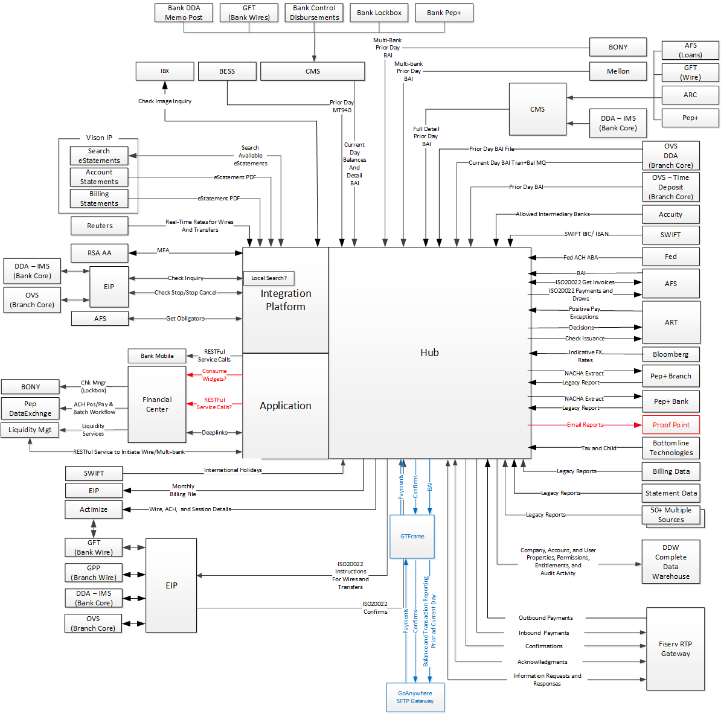

Figure 1 - Logical System Context

### Note that all interfaces will need to be encrypted between MUFG and Bottomline. This requirement must be taken into consideration regardless of transport, file format, or interface type.

NOTE - TAR 653: MUFG’s requirement is that Data at Rest including files contain sensitive information need to be encrypted using PGP in addition to channels. This is applicable to individual files and possibly file system folders/directories

### Integrations

The link to the spreadsheet below provides the interface worksheet detailing each interface, current status, and current owner.



# 

## Networking

### Networking Overview

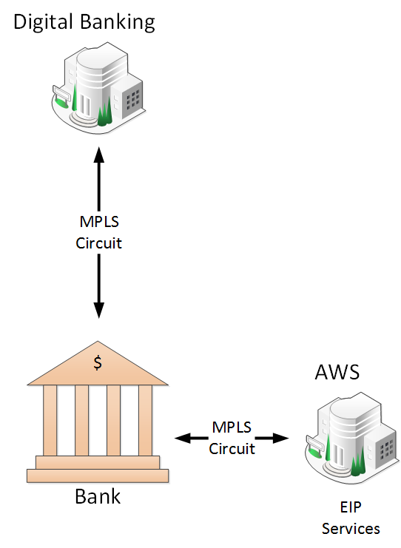

MUFG will be hosting their own SSO infrastructure and Transaction Banking Landing Page known as the Financial Center. This Financial Center application will perform deep links into Digital Banking as well as potentially consume widgets directly.

The bank also has their own mobile application which will call Digital Banking’s RESTful services.

The Financial Center also controls all outbound SSO integrations to Fiserv and other third parties.

The EIP services used for managing the Digital Banking to MUFG back-office interfaces on AWS, but this use of AWS will be transparent to Bottomline.

Figure 2 - Networking Diagram

### MPLS diagram

This section is just a place holder for future discussions to elaborate the connections between Digital Banking and the multiple back-office and DR deployments at MUFG.

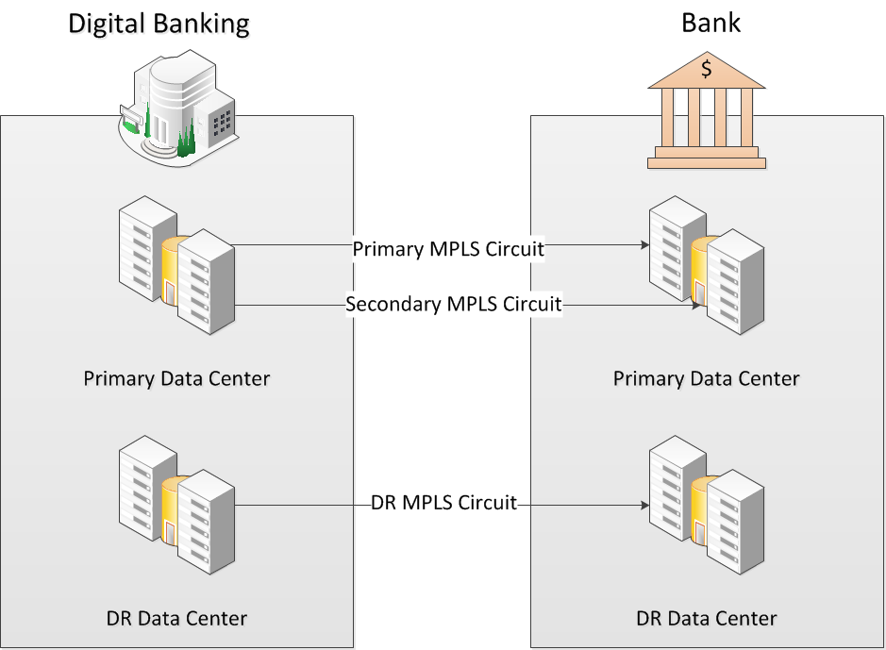

Figure 3 – MUFG MPLS Diagram

# System Integrations

This section documents project-specific requirements contributing to the implementation and configuration of the Digital Banking interfaces. This section is divided into sections by interface type

## File-Based Interfaces

These batch file interfaces are deployed on the Digital Banking Hub Tier. Instruction files that Digital Banking creates, such as ACH payments to be processed, are configured to run at specific times with follow-up or linked events that send Digital Banking created files on to their processing destination. Similarly files that are to be received and loaded into Digital Banking, are configured as events, where they are usually set up to load the file upon arrival.

## ACH Payment Instructions to the Back-Office

|  |  |  |  |  |  |  |
| --- | --- | --- | --- | --- | --- | --- |
| **Business Purpose** | **Interface System** | **Message Format** | **Transport** | **Intermediary** | **IDT Configuration Required** | **HLD Required** |
| Send ACH Payment Instructions to Back Office | Bank: PEP+ and AOD (Guardian)  Branch: AMH => PEP+ and AOD (Guardian) | NACHA  (two files for each ABA – IAT and non-IAT. *There will be no separate file for same day and pass through* | File | GIS | None | No |

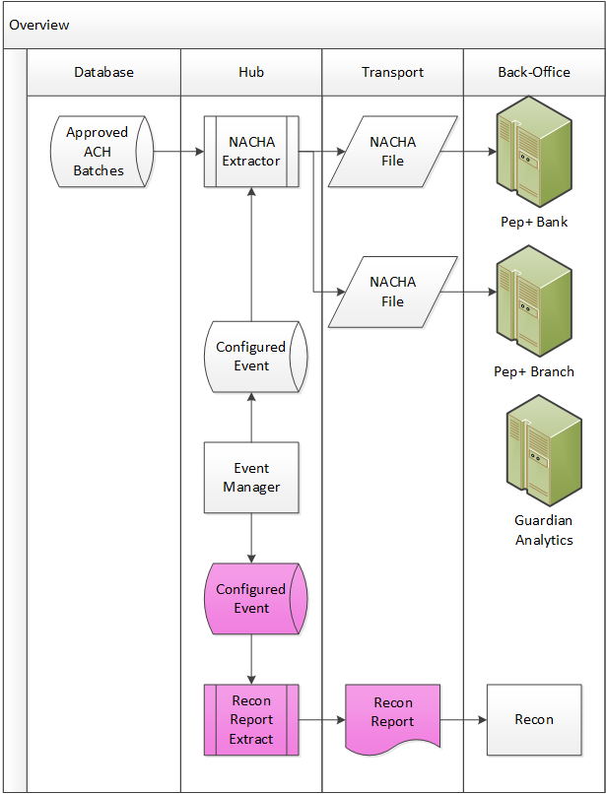

Product NACHA Extractor will be configured to Extract Approved ACH Payment batches on configured cut times within Hub Event configurations. Extracted NACHA Files will be transferred to ACH via SFTP, and there will be one set of files generated for the Bank instance and another for the Branch instance of Pep+.

Guardian Analytics: EIP team will generate a copy to Guardian Analytics for Branch.

The NACHA files will be scored by Guardian Analytics, but this scoring is completely transparent to Digital Banking – the files are sent to the two instances of PEP+.

The configuration of the extracts will need to meet the following schedule:

|  |  |  |  |  |  |  |
| --- | --- | --- | --- | --- | --- | --- |
|  | | **MUB (Bank)** | | | **MUFG (Branch)** | |
| Num | PEP out time | 1 | 2 | 3 | 4 | 5 |
|  | *All times ET* | *IAT* | *Same Day* | *2 Day* | *Same Day* | *2 Day* |
| 1 | 9:15 AM | X | X | X | X | X |
| 2 | 10:45 AM | X | X | X | X | X |
| 3 | 13:00 PM | X | X | X | X | X |
| 4 | 15:15 PM | X |  | X |  | X |
| 5 | 16:45 PM | X |  | X |  | X |
| 6 | 17:45 PM | X |  | X |  | X |
| 7 | 19:15 PM | X |  | X |  | X |
| 8 | 21:00 PM | X |  | X |  | X |
|  | No of sweeps | 8 | 3 | 8 | 3 | 8 |

There will be a custom extract created and scheduled to provide a payment reconciliation report in a TBD format. This extract will be configured to run upon completion of each NACHA extract.

## Reference Data Loads

|  |  |  |  |  |  |  |
| --- | --- | --- | --- | --- | --- | --- |
| **Business Purpose** | **Interface System** | **Message Format** | **Transport** | **Intermediary** | **IDT Configuration Required** | **HLD Required** |
| Provide updated list of ABA codes valid for ACH payments | Federal Reserve | Fed Format | File | No | No | No |
| Tax and Child Support Rules | Bottomline | Proprietary Bottomline | File | No | No | No |
| Provide updated list of ABA codes valid for Fed Wire payments | Federal Reserve | Fed Format | File | No | No | No |
| Provide International Bank Reference Data | SWIFT | Directory | File | No | No | No |
| Valid Intermediary Banks | Accuity | Accuity | File | No | Yes | Yes |
| FX Rates | Bloomberg | Proprietary  Bottomline | File | No | Yes | Yes |

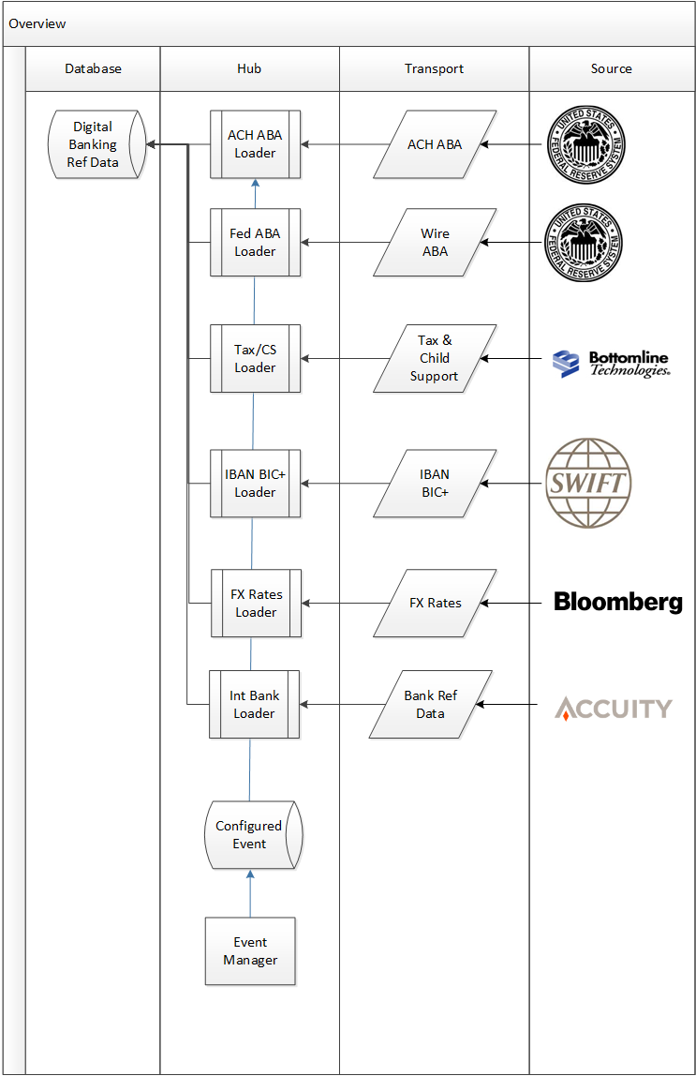

Each of the reference data events will be configured to load the file upon arrival – when the file is dropped in the designated directory, it will immediately load into the application. Product work will be required to create a standard loader of the Intermediary Bank reference data loader for Accuity. The data structures exist to support this load, and proprietary loads for the UK and Canada have been written, but we will need to support the standard file load from Accuity.

Tax and Child support updates will be delivered to MUFG and loaded using the bank’s procedures for production updates. Once loaded, the actual rules must be approved in the Admin UI before they become active.

## Prior-Day and Current Day BAI Loads

|  |  |  |  |  |  |  |
| --- | --- | --- | --- | --- | --- | --- |
| **Business Purpose** | **Interface System** | **Message Format** | **Transport** | **Intermediary** | **IDT Configuration Required** | **HLD Required** |
| Load Prior-Day Account Balances and Posted Transactions for Prior Day Account Reporting (Posted Balances and Transactions) | DDA via CMS | BAI2 | SFTP | None | TBD | No |
| OVS DDA | BAI2 | SFTP | None | TBD | No |
| OVS Time Deposits | BAI2 | SFTP | None | TBD | No |
| BONY | BAI2 | SFTP | None | TBD | No |
| Mellon | BAI2 | SFTP | None | TBD | No |
| Load Current-Day Account Balances and Transaction Advices for Current Day Account Reporting | DDA via CMS | BAI2 | SFTP | None | TBD | No |
| OVS DDA | BAI2 | SFTP | None | TBD | No |

Each of the BAI events will be configured to load the file upon arrival – when the file is dropped in the designated directory, it will immediately load into the application.

Digital Banking will expect to receive this file daily, and will generate a system alert if it does not arrive within an expected time frame.

Currently Digital Banking’s transaction list view will optionally display the running balance based on the sequence in which it was loaded. This running balance only shows up in the list view when the display sequence is the order in which they were received. There is currently an issue in that the order in which Digital Banking receives the transactions will be incorrect, hence the balance would not truly reflect the actual running balance. There may be a need for an enhancement to allow the bank to pass in the sequence number.

Digital Banking separates the bank transactions from the advice detail linked by a unique key.

## Prior Day Bank DDA to CMS

CMS combines information from other systems to create an enriched BAI file that will be sent to Digital Banking as shown below:

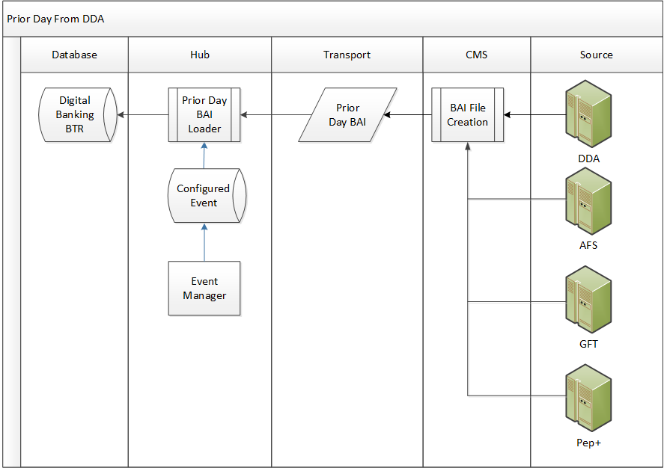

## Prior Day Branch OVS

There will be two discreet Prior-Day loads from OVS, one for the DDA accounts, and one for the Time Deposit Accounts as shown below:

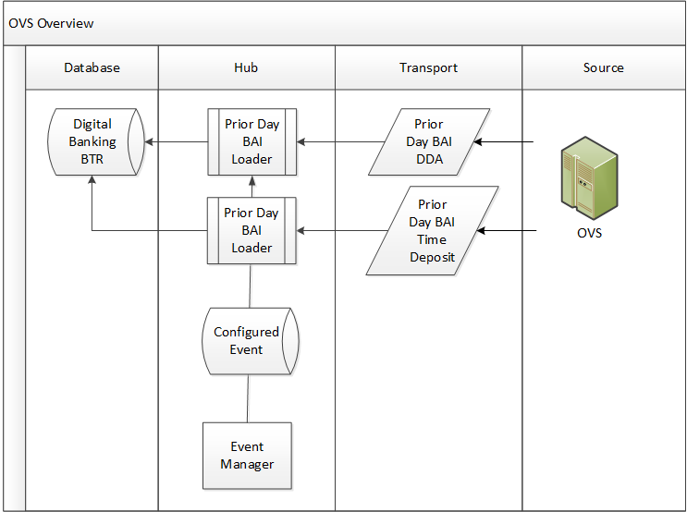

Digital Banking separates the bank transactions from the advice detail linked by a unique key. This allows transaction detail provided by the current day transactions to be linked to the next day’s prior day transactions allowing for the purging of current day transactions while keeping the advice detail to allow the prior day equivalent transaction to be supplemented by that detail.

## Prior Day Branch Multi-Bank Reporting

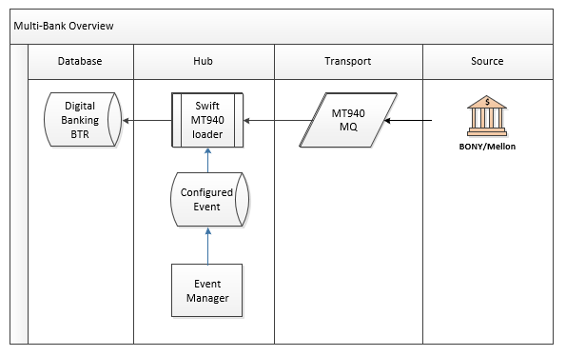

## Current Day Bank DDA to CMS

Current day BAI files can be sent at any time and will be immediately loaded for client access. Digital Banking will assume intraday BAI files are incremental.

* *Bank has mixed transmissions. Wires and RTP intraday transactions come through MQ channel. All the remaining intraday files will be sent as a batch file through GIS*

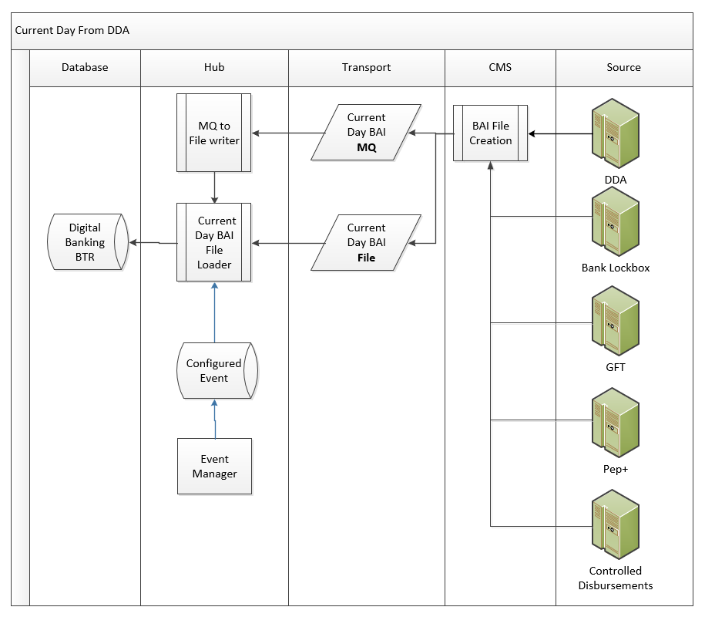

Currently Digital Banking’s transaction list view will optionally display the running balance based on the sequence in which it was loaded. This running balance only shows up in the list view when the display sequence is the order in which they were received. There is currently an issue in that the order in which Digital Banking receives the transactions will be incorrect, hence the balance would not truly reflect the actual running balance. There may be a need for an enhancement to allow the bank to pass in the sequence number.

Digital Banking separates the bank transactions from the advice detail linked by a unique key. This allows transaction detail provided by the current day transactions to be linked to the next day’s prior day transactions allowing for the purging of current day transactions while keeping the advice detail to allow the prior day equivalent transaction to be supplemented by that detail.

## Current Day Branch OVS

Current day BAI files can be sent at any time and will be immediately loaded for client access. Digital Banking will assume intraday BAI files are incremental.

**\*File and MQ Channels**

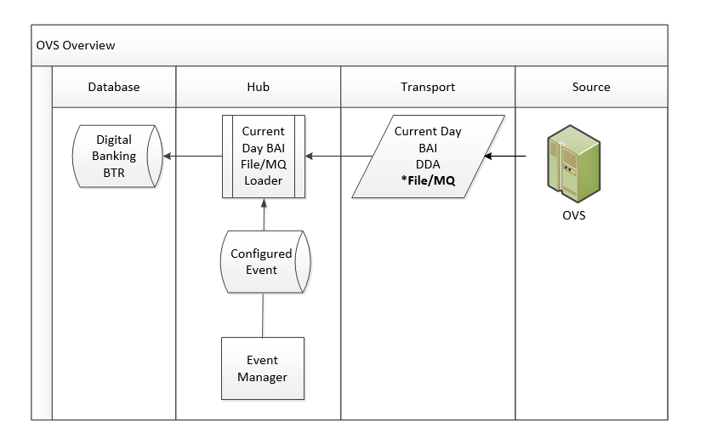

## Loan Balances and Transactions (P3)

Current balance and summary information is provided in BAI format in an unsolicited manner.

The prior-day transactions for loan accounts will be prepared by CMS and sent with the other prior day account information sent for the bank DDA.

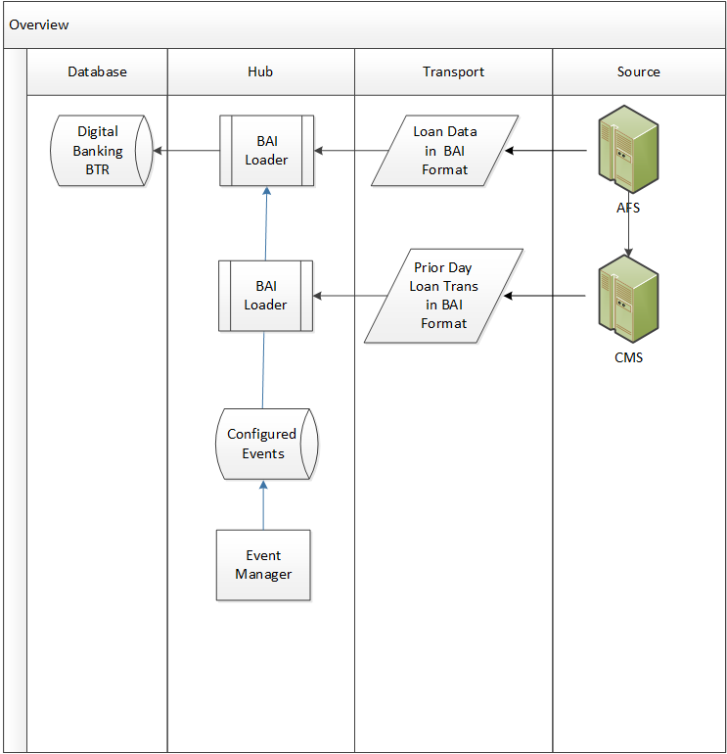

## LIBOR Rates Feed

This feed is required to provide interest rate information to supplement the loan information being reported on.

## Loan 1098 Tax Form Reporting

This information will be retrieved through Legacy Reporting. Although logically linked to Loan Reporting, it should be simply considered another legacy report.

## Lockbox Reporting

Lockbox reporting will be handled through CMS current day BAI files and BONY BAI files. The lockbox transactional data will be included in the normal account transaction reporting as deposit transactions.

Bank will send lock BAI file transactions and Lockbox legacy report. Bank is not using the propriety CSV lockbox formatting. Information is displayed via lockbox avail reporting – event id 10036 Lockbox Availability Loader

The lockbox reporting file formats are a proprietary CSV format that can be combined with BAI data. If this interface/module is going to be utilized, it will require an HLD to define both the format MUFG can provide in conjunction with the report capabilities the bank would want to provide.

## Legacy Reporting

|  |  |  |  |  |  |  |
| --- | --- | --- | --- | --- | --- | --- |
| **Business Purpose** | **Interface System** | **Message Format** | **Transport** | **Intermediary** | **IDT Configuration Required** | **HLD Required** |
| Provide mechanism for delivering back-office reports to customers | TBD | Report and Files | SFTP | TBD | TBD | TBD |

MUFG has the following legacy reports

ACH.NOCR ACH Returns/NOC Report

ACH.CDER ACH Collection Detail Entry Report

LB.DPR Deposits Processed Report

LB.DR Lockbox Detail Report

LB.EDR Lockbox Extended Detail Report

EDI.RDR Receivables Detail Report

LQ.MMAR Money Market Account Report

LQ.MMER Money Market Escrow Report

LQC.SS Sweep Statements

RI.LDEW Return Item & Large Dollar Early Warning

LQ.CPSR Cash Pooling Summary

LQ.CPDR Cash Pooling Detailed

ACH.OR ACH Origination Report

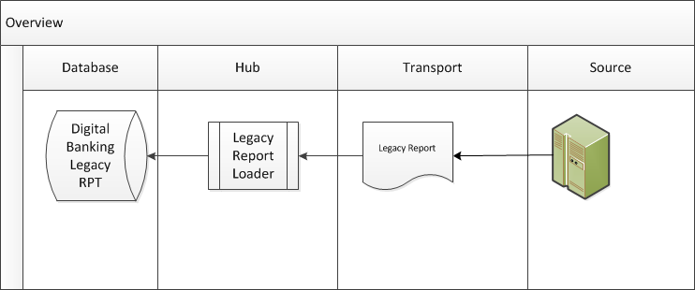

## Check Issuance Extract (P3)

|  |  |  |  |  |  |  |
| --- | --- | --- | --- | --- | --- | --- |
| **Business Purpose** | **Interface System** | **Message Format** | **Transport** | **Intermediary** | **IDT Configuration Required** | **HLD Required** |
| Extract Customer Check issuances to the back-office for positive pay | ART | Product Format | SFTP | None | TBD | TBD |

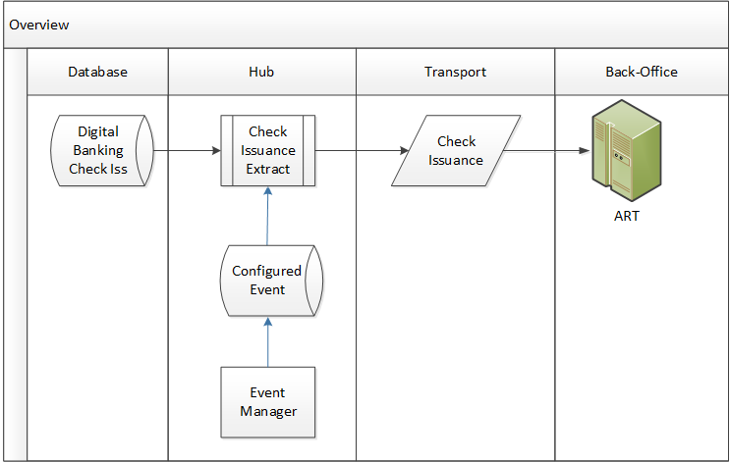

## Positive Pay Exception Loader (P3)

|  |  |  |  |  |  |  |
| --- | --- | --- | --- | --- | --- | --- |
| **Business Purpose** | **Interface System** | **Message Format** | **Transport** | **Intermediary** | **IDT Configuration Required** | **HLD Required** |
| Load exceptions for client decisions | ART | TBD | SFTP | None | TBD | TBD |

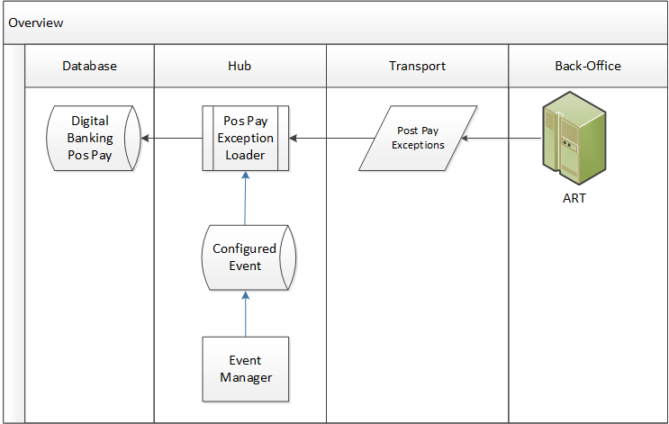

We will need to know from DGB which accounts are set up for positive pay. We will need to communicate which accounts are set up for Positive Pay Decisions within DGB either through exposing a service or sending a file.

## Positive Pay Decision Extractor (P3)

|  |  |  |  |  |  |  |
| --- | --- | --- | --- | --- | --- | --- |
| **Business Purpose** | **Interface System** | **Message Format** | **Transport** | **Intermediary** | **IDT Configuration Required** | **HLD Required** |
| Extract Client decisions | ART | TBD | SFTP | None | TBD | TBD |

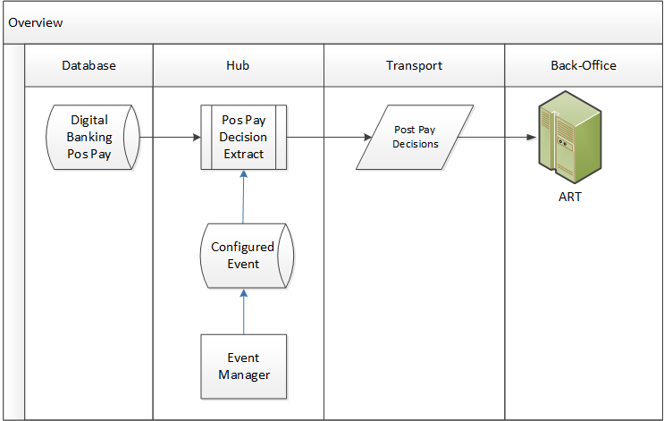

## Reverse Positive Pay Exception Loader (P3)

|  |  |  |  |  |  |  |
| --- | --- | --- | --- | --- | --- | --- |
| **Business Purpose** | **Interface System** | **Message Format** | **Transport** | **Intermediary** | **IDT Configuration Required** | **HLD Required** |
| Load exceptions for client decisions | ART | TBD | SFTP | None | TBD | TBD |

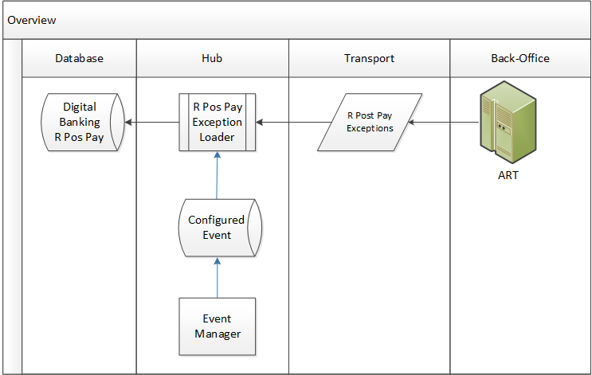

## Reverse Positive Pay Decision Extractor (P3)

|  |  |  |  |  |  |  |
| --- | --- | --- | --- | --- | --- | --- |
| **Business Purpose** | **Interface System** | **Message Format** | **Transport** | **Intermediary** | **IDT Configuration Required** | **HLD Required** |
| Extract Client decisions | ART | TBD | SFTP | None | TBD | TBD |

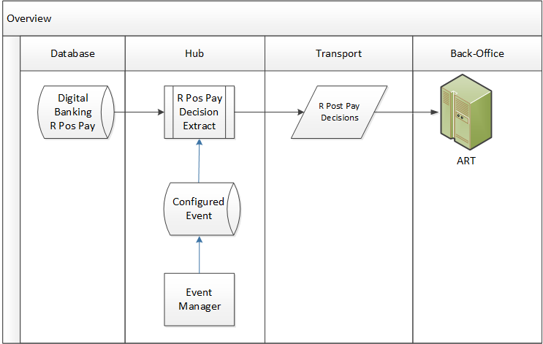

## Billing Extract

|  |  |  |  |  |  |  |
| --- | --- | --- | --- | --- | --- | --- |
| **Business Purpose** | **Interface System** | **Message Format** | **Transport** | **Intermediary** | **IDT Configuration Required** | **HLD Required** |
| Extract information to be used for client billing | RDC (AAA) | Bottomline  Configured | SFTP | GIS | Yes | Yes |

For the customer billing system interface, DTB (Bottomline) will transmit their standard billing extract file through MUB GIS to MUB Relationship Data Collector (RDC), a sub system of Automated Account Analysis AAA. Any enhancements for Bottomline billing extract file shall be delivered in the same billing extract file if required billing data not available in the current file.

For the purposes of this document, we treat RDV (subsystem of AAA) as an endpoint for receiving the monthly billing extract file from Digital Banking.

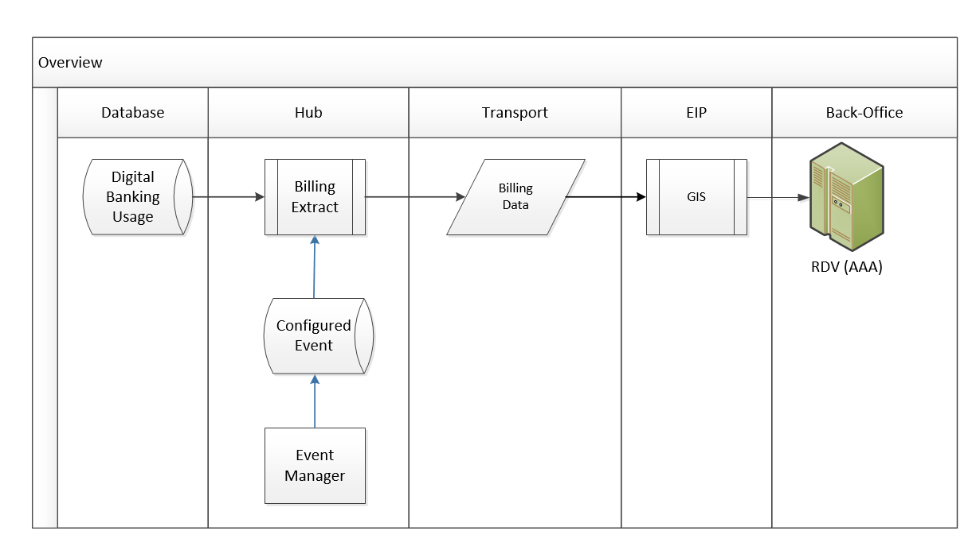

There will be one implementation of the billing extract which the bank will derive what it needs from the bank code on the account, and the market segment based on the customer ID. The billing extract will be configured with additional billing codes and data elements required by MUFG. This will be configured using the DB metadata/custom SQL’s.

## Audit and Customer/User Detail Extract

|  |  |  |  |  |  |  |
| --- | --- | --- | --- | --- | --- | --- |
| **Business Purpose** | **Interface System** | **Message Format** | **Transport** | **Intermediary** | **IDT Configuration Required** | **HLD Required** |
| Provide Audit Reporting to back-office | DDW | Pipe delimited` | SFTP | None | Yes | Yes |

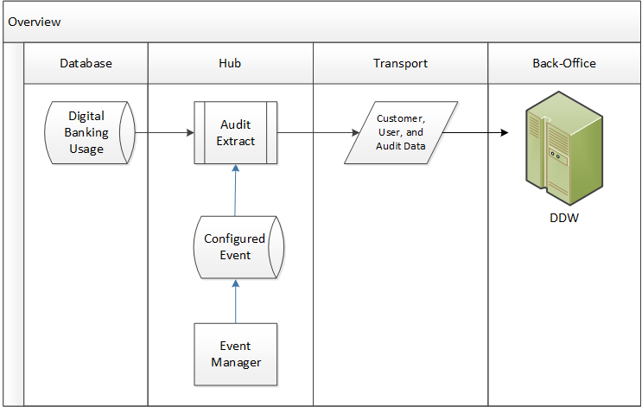

Periodically (TBD) all information regarding company setup, account setup, user setup, permissions, limits, and incremental audit information will be extracted and sent to the enterprise data warehouse system DDW.

Exact scope, format, and number of files TBD. HLD will be required. There will need to be multiple audit extracts covering various views of the client audit information. The Product Audit Extracts will need to be enhanced to allow for extracting client audit information with various filters applied to allow for the data to be segmented to line up with the bank’s requirements.

* 21027 Recert - Roles
* 21026 Recert - RoleEnt
* 21025 Recert - UserRoles
* 21024 Recert - Actions
* 21023 Recert - Types
* 21022 Recert - Function Groups
* 21021 Recert - Functions
* 21020 Recert - Products
* 21051 Avalon Wire Extract CTL
* 21050 Avalon Wire Extract CSV
* 21031 CRM Account Extract

## Holiday Reference Data Load

|  |  |  |  |  |  |  |
| --- | --- | --- | --- | --- | --- | --- |
| **Business Purpose** | **Interface System** | **Message Format** | **Transport** | **Intermediary** | **IDT Configuration Required** | **HLD Required** |
| Currency Holiday loader | MUFG | IDT configured | SFTP | None | Yes | Yes |

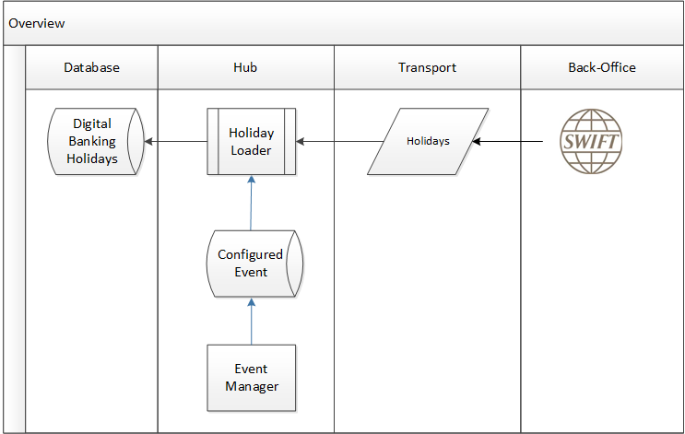

## ACH Positive Pay Exception Loader (Not in Scope)

|  |  |  |  |  |  |  |
| --- | --- | --- | --- | --- | --- | --- |
| **Business Purpose** | **Interface System** | **Message Format** | **Transport** | **Intermediary** | **IDT Configuration Required** | **HLD Required** |
| Load ACH Suspects for client decisions |  |  |  |  |  |  |

## ACH Positive Pay Decision Extractor (Not in Scope)

|  |  |  |  |  |  |  |
| --- | --- | --- | --- | --- | --- | --- |
| **Business Purpose** | **Interface System** | **Message Format** | **Transport** | **Intermediary** | **IDT Configuration Required** | **HLD Required** |
| Extract Client decisions |  |  |  |  |  |  |

## Real-Time Synchronous Interfaces

This category of interface is primarily implemented using a SOAP/HTTP design pattern, but regardless, these interfaces use the Digital Banking Integration Platform, the product tier explicitly designed for real-time synchronized interfaces with the back-office where there is a user/customer waiting for the service response. The Integration Platform tier provides a mechanism to connect standard product interfaces to the corresponding bank-specific interfaces deployed to support the corresponding business services.

## Error Messages and Host Response Code Handling

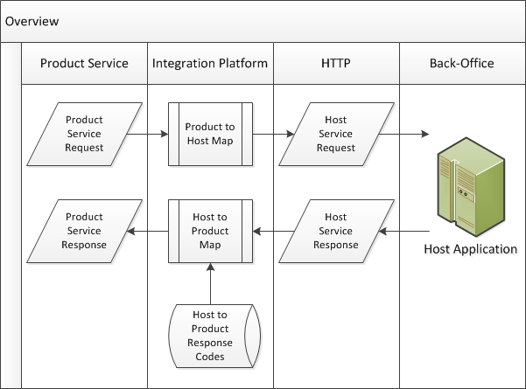

The bank EIP layer will translate the host-specific transaction codes to the standard Digital Banking Transaction codes. This will continue the strategy of minimizing any IDT configuration work. The actual text resolved from the Digital Banking transaction codes can be configured, and is locale-aware.

SADD_– Need to make a decision whether DGB will send out the user locale in the request and EIP will translate the error messages or if MUFG will send back a locale code and DGB will translate the message.

Decision: DGB will send out the user locale in the request payload.

## Check Inquiry

This section describes interface that performs a real-time request to get information from the back-office regarding checks.

|  |  |  |  |  |  |  |
| --- | --- | --- | --- | --- | --- | --- |
| Business Purpose | Interface System | Message Format | Transport | Intermediary | IDT Configuration Required | HLD Required |
| Client Requests Check Details | Bank CMS and Branch OVS | SOAP Product OOB | HTTPS | EIP | No | No |
| Receive Check Details for Client Inquiry | Bank CMS and Branch OVS | SOAP Product OOB | HTTPS | EIP | No | No |

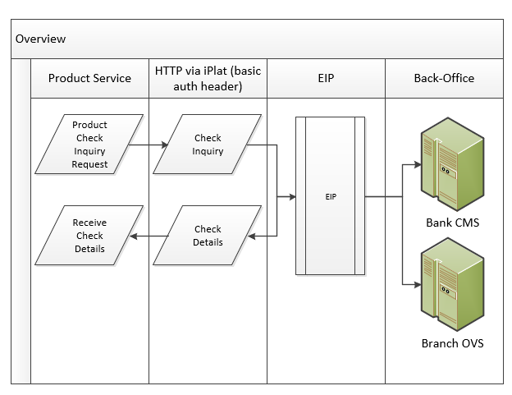

## Check Inquiry - Stopped Checks (not in scope – handled by check inquiry)

Although Digital Banking normally utilizes one check inquiry service, this implementation will utilize two discreet services: one for Stopped Checks and one for Paid Checks. This section describes the Stop Check Inquiry.

|  |  |  |  |  |  |  |
| --- | --- | --- | --- | --- | --- | --- |
| Business Purpose | Interface System | Message Format | Transport | Intermediary | IDT Configuration Required | HLD Required |
| Client Requests Stopped Check Details |  |  |  |  |  |  |
| Receive Stop Check Details for Client Inquiry |  |  |  |  |  |  |

## Check Inquiry - Paid Items (not in scope – handled by check inquiry)

Although Digital Banking normally utilizes one check inquiry service, this implementation will utilize two discreet services: one for Stopped Checks and one for Paid Checks. This section describes the Paid Check Inquiry.

|  |  |  |  |  |  |  |
| --- | --- | --- | --- | --- | --- | --- |
| Business Purpose | Interface System | Message Format | Transport | Intermediary | IDT Configuration Required | HLD Required |
| Client Requests Paid Check Details |  |  |  |  |  |  |
| Receive Stop Check Details for Client Inquiry |  |  |  |  |  |  |

## Cancel Stop Check -Single Item

There are two services available to perform a Cancel Stop Check function: one service stops a single item, and one service stops a range of items. This section describes the single item stop service.

|  |  |  |  |  |  |  |
| --- | --- | --- | --- | --- | --- | --- |
| Business Purpose | Interface System | Message Format | Transport | Intermediary | IDT Configuration Required | HLD Required |
| Stop Single Check | Bank CMS and Branch OVS | SOAP Product OOB | HTTPS | EIP | No | No |
| Receive Stop Request Status | Bank CMS and Branch OVS | SOAP Product OOB | HTTPS | EIP | No | No |

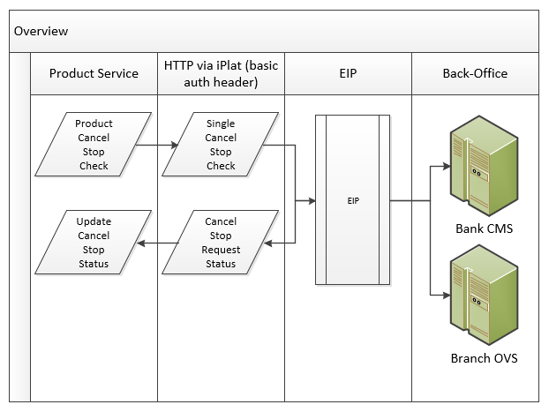

## Stop Check (Range or Single)

There are two services available to perform a stop check or stop cancel function: this service stops/stop cancels both a single item, as well as a range of items. This section describes this service.

|  |  |  |  |  |  |  |
| --- | --- | --- | --- | --- | --- | --- |
| Business Purpose | Interface System | Message Format | Transport | Intermediary | IDT Configuration Required | HLD Required |
| Stop a range of checks to Stop or Stop Cancel Requests | Bank CMS and Branch OVS | SOAP Product OOB | HTTPS | EIP | No | No |
| Receive statuses for each request | Bank CMS and Branch OVS | SOAP Product OOB | HTTPS | EIP | No | No |

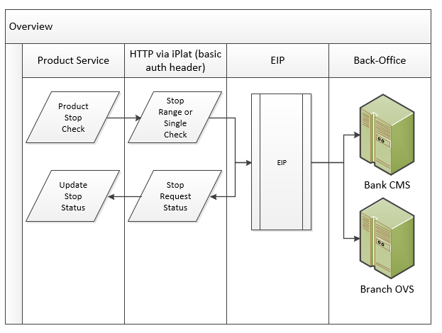

## Deposit Ticket Item List Retrieval (P3??)

|  |  |  |  |  |  |  |
| --- | --- | --- | --- | --- | --- | --- |
| Business Purpose | Interface System | Message Format | Transport | Intermediary | IDT Configuration Required | HLD Required |
| Request for list of deposit items on deposit ticket |  | SOAP | HTTPS | EIP | TBD | No |
| Receive list of items |  | SOAP | HTTPS | EIP | TBD | No |

## Real-Time Account Balance Retrieval (Not in Scope)

|  |  |  |  |  |  |  |
| --- | --- | --- | --- | --- | --- | --- |
| Business Purpose | Interface System | Message Format | Transport | Intermediary | IDT Configuration Required | HLD Required |
| Request Real-Time Balance |  | SOAP | HTTPS | EIP | TBD | No |
| Receive Real-Time Balance |  | SOAP | HTTPS | EIP | TBD | No |

## Real-Time Account Transaction Retrieval (Not in Scope)

This service is used to provide customers with all their current day transactions directly from the back-office using a real-time request incremental current day request when looking at transactions within a given account or set of accounts.

|  |  |  |  |  |  |  |
| --- | --- | --- | --- | --- | --- | --- |
| Business Purpose | Interface System | Message Format | Transport | Intermediary | IDT Configuration Required | HLD Required |
| Request Real-Time Current Day Transactions |  | SOAP | HTTPS | EIP | TBD | No |
| Receive Real-Time Current Day Transactions |  | SOAP | HTTPS | EIP | TBD | No |

## Deposit Ticket Image Retrieval (P3)

|  |  |  |  |  |  |  |
| --- | --- | --- | --- | --- | --- | --- |
| Business Purpose | Interface System | Message Format | Transport | Intermediary | IDT Configuration Required | HLD Required |
| Request Deposit Ticket Image | IBX | SOAP | HTTPS | EIP | TBD | No |
| Receive Deposit Ticket Image | IBX | SOAP | HTTPS | EIP | TBD | No |

## Image Search

   MUFG - image search will be available via VisionIP (Customer Check Paid Image).  Lockbox check image will need to be viewed on BNYM Check Manager.

  MUB - image search will be available via IBX. Applicable to both Check Images and Deposit Images.

|  |  |  |  |  |  |  |
| --- | --- | --- | --- | --- | --- | --- |
| Business Purpose | Interface System | Message Format | Transport | Intermediary | IDT Configuration Required | HLD Required |
| Request List of Available Images |  | SOAP | HTTPS | EIP | Yes | No |
| Receive List of Available Images |  | SOAP | HTTPS | EIP | Yes | No |

## Deposit Ticket Detail Item Image Retrieval (P3)

|  |  |  |  |  |  |  |
| --- | --- | --- | --- | --- | --- | --- |
| Business Purpose | Interface System | Message Format | Transport | Intermediary | IDT Configuration Required | HLD Required |
| Request Deposit Ticket Image |  | SOAP | HTTPS | EIP | TBD | No |
| Receive Deposit Ticket Image |  | SOAP | HTTPS | EIP | TBD | No |

## Deposit Ticket Return Item Image Retrieval (Not in Scope)

|  |  |  |  |  |  |  |
| --- | --- | --- | --- | --- | --- | --- |
| Business Purpose | Interface System | Message Format | Transport | Intermediary | IDT Configuration Required | HLD Required |
| Request Deposit Ticket Image |  | SOAP | HTTPS | EIP | TBD | No |
| Receive Deposit Ticket Image |  | SOAP | HTTPS | EIP | TBD | No |

*TAR 638: Confirmed that Return Item Image is not available for Bank, and therefore not in scope for Avalon 3. Mark as out-of-scope.*

## Check Image Retrieval

|  |  |  |  |  |  |  |
| --- | --- | --- | --- | --- | --- | --- |
| Business Purpose | Interface System | Message Format | Transport | Intermediary | IDT Configuration Required | HLD Required |
| Request Check Image | VisionIP(P2) IBX(P3) | SOAP | HTTPS | EIP | No | No |
| Receive Check Image | VisionIP(P2) IBX(P3) | SOAP | HTTPS | EIP | No | No |

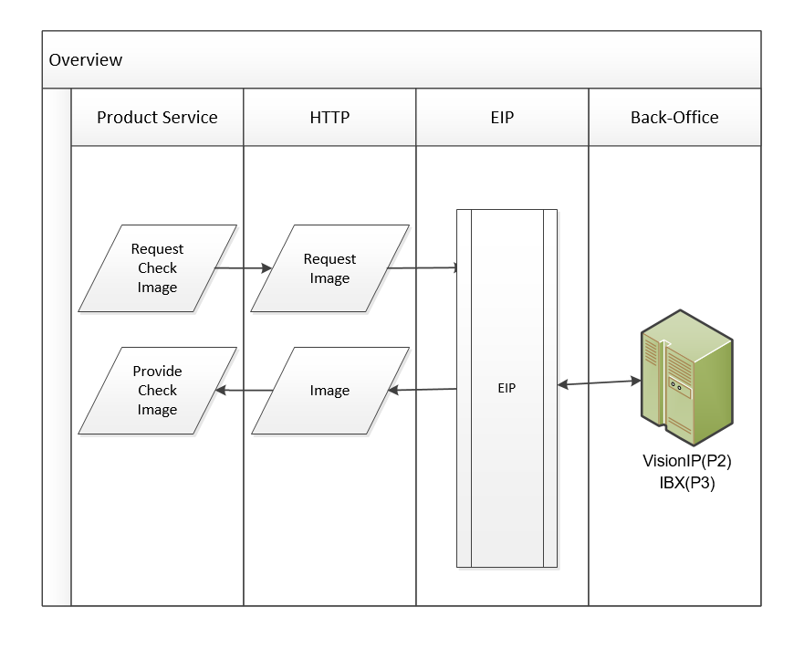

## Get eStatement List

This service provides the customer with a list of eStatements that are available for downloading. These can either be Account eStatements or Billing eStatements.

In the BTL payload, there is Account ID and ABA number which will distinguish Bank (P3) vs Branch (P2).

|  |  |  |  |  |  |  |
| --- | --- | --- | --- | --- | --- | --- |
| Business Purpose | Interface System | Message Format | Transport | Intermediary | IDT Configuration Required | HLD Required |
| Get a list of available eStatements | VisionIP(P2) IBX(P3) | SOAP | HTTPS | EIP | Yes | No |
| Receive list of available eStatements | VisionIP(P2) IBX(P3) | SOAP | HTTPS | EIP | Yes | No |

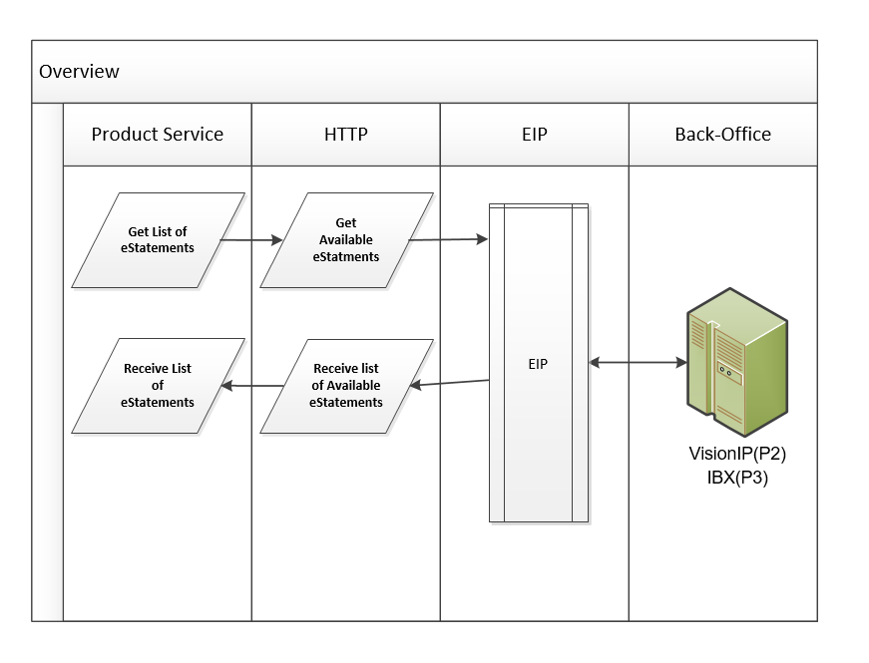

## eStatement Retrieval

This service retrieves an eStatement by the ID that was returned by the Get List of Available eStatments service call.

|  |  |  |  |  |  |  |
| --- | --- | --- | --- | --- | --- | --- |
| Business Purpose | Interface System | Message Format | Transport | Intermediary | IDT Configuration Required | HLD Required |
| Get eStatement | Vision IP | SOAP | HTTPS | EIP | TBD | No |
| Receive eStatement | Vision IP | SOAP | HTTPS | EIP | TBD | No |

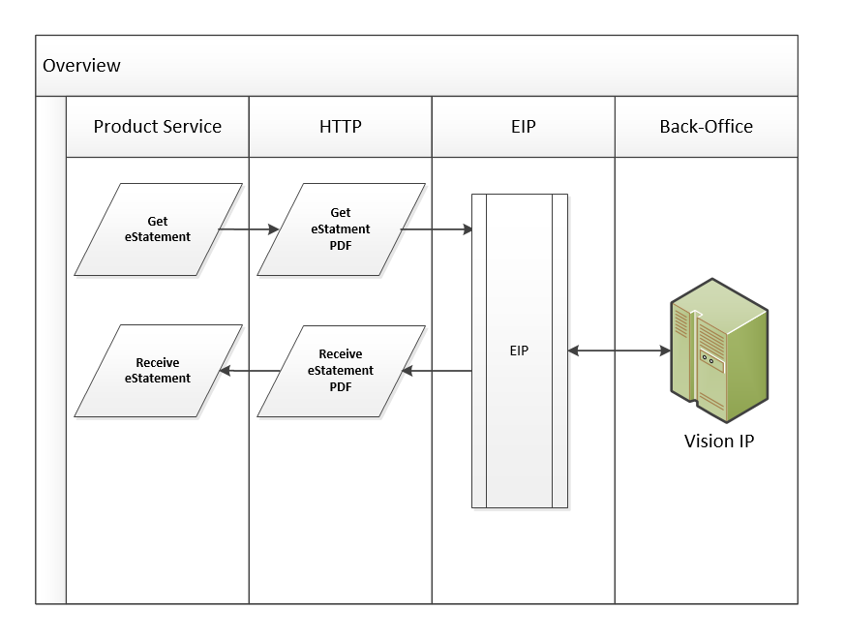

## Real Time Loan Reporting (P3)

|  |  |  |  |  |  |  |
| --- | --- | --- | --- | --- | --- | --- |
| Business Purpose | Interface System | Message Format | Transport | Intermediary | IDT Configuration Required | HLD Required |
| Get Invoices | AFS | SOAP | HTTPS | EIP | TBD | No |
| Receive Invoices | AFS | SOAP | HTTPS | EIP | TBD | No |
| Receive Intra-Day Balance and Transaction Reporting | AFS | BAI | SFTP | None | TBD | No |

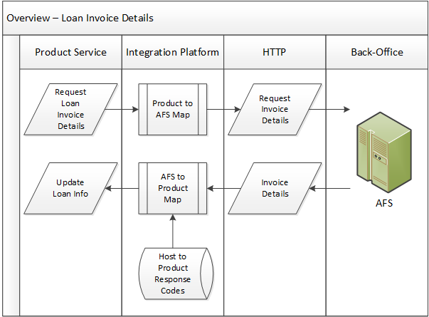

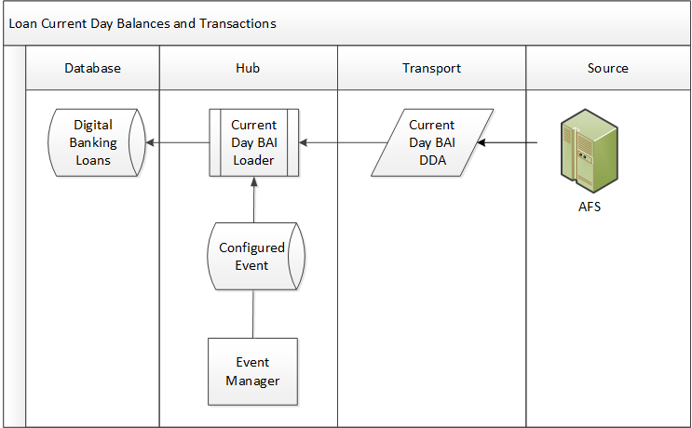

## Loan Payment and Draws (P3) (MQ)

|  |  |  |  |  |  |  |
| --- | --- | --- | --- | --- | --- | --- |
| Business Purpose | Interface System | Message Format | Transport | Intermediary | IDT Configuration Required | HLD Required |
| Perform Real-Time Loan Transactions (payments and draws) | AFS | ISO20022 | MQ | None | Yes | No |
| Receive Loan Release Status | AFS | ISO20022 | MQ | None | TBD | No |

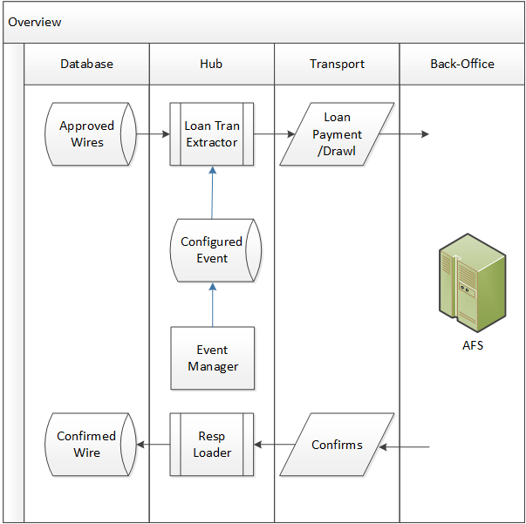

## Real-Time Transfers (MQ)

|  |  |  |  |  |  |  |
| --- | --- | --- | --- | --- | --- | --- |
| Business Purpose | Interface System | Message Format | Transport | Intermediary | IDT Configuration Required | HLD Required |
| Perform Real-Time Account Transfers | OVS/DDA | ISO20022 | MQ | EIP | TBD | No |
| Receive transfer execution status | OVS/DDA | ISO20022 | MQ | EIP | TBD | No |

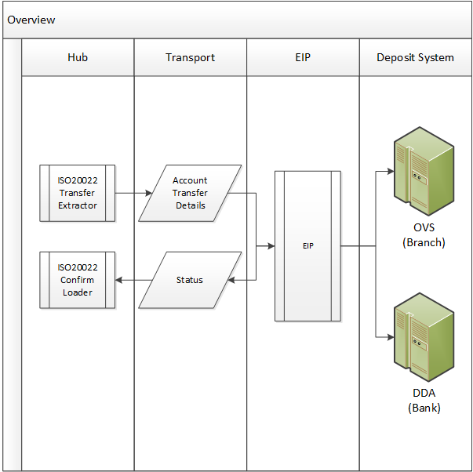

## MFA Approval

This service all is performed to ensure the identity of the user during required MFA interdiction.

|  |  |  |  |  |  |  |
| --- | --- | --- | --- | --- | --- | --- |
| Business Purpose | Interface System | Message Format | Transport | Intermediary | IDT Configuration Required | HLD Required |
| Perform MFA Request | RSA AA | SOAP | HTTPS | EIP | TBD | No |
| Receive MFA Response | RSA AA | SOAP | HTTPS | EIP | TBD | No |

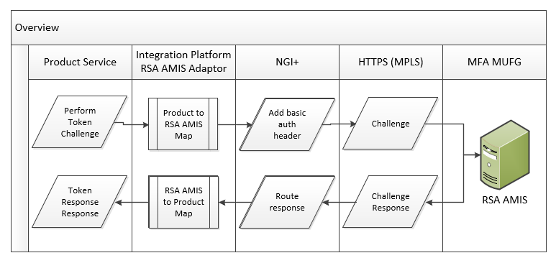

## Customer Setup and User Approval (INBOUND)

This is a service call provided by Digital Banking to allow customer setup, users, and roles to be approved or rejected, where the rejection action will roll-back the setup information to its prior state.

|  |  |  |  |  |  |  |
| --- | --- | --- | --- | --- | --- | --- |
| Business Purpose | Interface System | Message Format | Transport | Intermediary | IDT Configuration Required | HLD Required |
| Allow Bank and Customer Admin Users to Approve/Commit setup information | FC/SSO | SOAP/  restFul | HTTPS | EIP | TBD | No |
| Allow Bank and Customer Admin Users to Reject Setup information and roll-back setup information to prior state | FC/SSO | SOAP/  restFul | HTTPS | EIP | TBD | No |
| Communicate success or failure of service request | FC/SSO | SOAP/  restFul | HTTPS | EIP | TBD | No |

## Alerts Extract (Realtime restFul call)

Digital Banking will create the message payload including Velocity template and locale formatting – the payload is routed to MUFG via a restFul call for transmission via SMTP

|  |  |  |  |  |  |  |
| --- | --- | --- | --- | --- | --- | --- |
| Business Purpose | Interface System | Message Format | Transport | Intermediary | IDT Configuration Required | HLD Required |
| Communicate application alerts | CMB | JSON | MQ | EIP | Yes | TBD |
| Receive receipt status | CMB | JSON | MQ | EIP | Yes | TBD |

## Balance Retrieval for One Account (Not In Scope)

There will not be a host interface to perform this function. Instead, Digital Banking will do a local query to access the current balance for the debit account.

## Balance Check for One Account

This service is used to provide a user a current balance on an account while initiating a payment or account transfer transaction.

|  |  |  |  |  |  |  |
| --- | --- | --- | --- | --- | --- | --- |
| Business Purpose | Interface System | Message Format | Transport | Intermediary | IDT Configuration Required | HLD Required |
| To provide user with current balance of a debit or credit account |  | SOAP | HTTPS | EIP | TBD | No |
| Receive Current Balance for display on transaction screen |  | SOAP | HTTPS | EIP | TBD | No |

## Pre-funding Check

This service is used to perform a HOLD (only) a funding account upon payment approval. This interface needs to be elaborated in more detail.

|  |  |  |  |  |  |  |
| --- | --- | --- | --- | --- | --- | --- |
| Business Purpose | Interface System | Message Format | Transport | Intermediary | IDT Configuration Required | HLD Required |
| Request hold or debit on funding account upon payment approval | ??? | SOAP | HTTPS | EIP | TBD | No |
| Receive status of request | ??? | SOAP | HTTPS | EIP | TBD | No |

## Get Real-Time Rate

Get a current FX rate for a currency pair.

|  |  |  |  |  |  |  |
| --- | --- | --- | --- | --- | --- | --- |
| Business Purpose | Interface System | Message Format | Transport | Intermediary | IDT Configuration Required | HLD Required |
| Get Real-Time FX Rate for Currency Pairs | Reuters | SOAP | HTTPS | EIP | TBD | No |
| Receive Real-Time FX Rates | Reuters | SOAP | HTTPS | EIP | TBD | No |

## Perform FX Trade

Perform spot FX Trade for a specific cross-currency payment.

|  |  |  |  |  |  |  |
| --- | --- | --- | --- | --- | --- | --- |
| Business Purpose | Interface System | Message Format | Transport | Intermediary | IDT Configuration Required | HLD Required |
| Perform Real-Time FX Trade | Reuters | SOAP | HTTPS | EIP | TBD | No |
| Receive Trade Confirmation | Reuters | SOAP | HTTPS | EIP | TBD | No |

## Validate Contract

Validate a manually entered FX contract to be associated to a given cross-currency payment.

TBD – NEED TAR for changing the Validate contract logic to retrieve the rate based on the Contract ID

|  |  |  |  |  |  |  |
| --- | --- | --- | --- | --- | --- | --- |
| Business Purpose | Interface System | Message Format | Transport | Intermediary | IDT Configuration Required | HLD Required |
| Validate an FX Contract ID and Rate | CMB | SOAP | HTTPS | EIP | TBD | No |
| Receive Validation Message | CMB | SOAP | HTTPS | EIP | TBD | No |















## Get Obligation per Obligators (P3)

|  |  |  |  |  |  |  |
| --- | --- | --- | --- | --- | --- | --- |
| Business Purpose | Interface System | Message Format | Transport | Intermediary | IDT Configuration Required | HLD Required |
| Request Obligations | AFS | TBD | SOAP/HTTPS | None | TBD | TBD |
| Receive requested Obligations | AFS | TBD | SOAP/HTTPS | None | TBD | TBD |

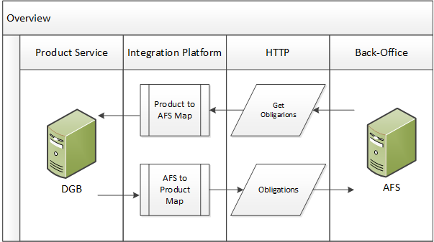

## Asynchronous Message Interfaces

This category of interface utilizes MQ or some equivalent asynchronous messaging service. This design pattern is generally used for RTGS payments and confirmations, sending and receiving customer and user setup (using SPML messages), All of the messages following this design pattern are deployed on the Digital Banking Hub Tier. The Hub manages events where periodic data/transaction extracts can be scheduled, as well as loaders that can be configured to “listen” on a message queue.

## Wire Initiation and Confirmation

|  |  |  |  |  |  |  |
| --- | --- | --- | --- | --- | --- | --- |
| Business Purpose | Interface System | Message Format | Transport | Intermediary | IDT Configuration Required | HLD Required |
| Send Wire Instructions | GPP/GFT | ISO20022 | MQ | EIP | No | No |
| Receive Wire Confirmations and Rejections | GPP/GFT | ISO20022 | MQ | EIP | No | No |

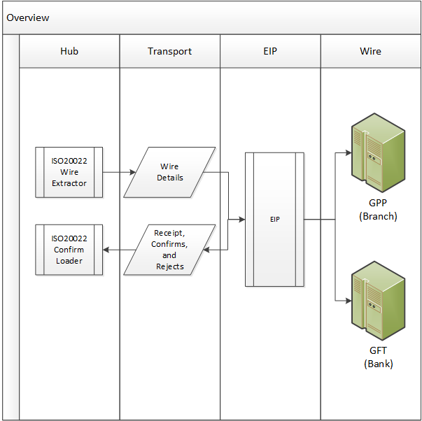

Wire Extracts are configured at set close intervals to provide near real-time wire processing. Each Extract will select all approved wire payments across the client base and commit them to an MQ transmission to EIP that will in turn route it to GFT (Bank) or GPP (Branch). Receipt acknowledgements, confirms, and rejects will return status updates to Digital Banking which will in turn update the wire payment’s status appropriately

## Customer Provisioning – Receive ((MIGRATION))

**This will be created by the DGB migration utility (P2)**

|  |  |  |  |  |  |  |
| --- | --- | --- | --- | --- | --- | --- |
| Business Purpose | Interface System | Message Format | Transport | Intermediary | IDT Configuration Required | HLD Required |
| Receive Customer Setup Information to Persist in Digital Banking |  | SPML |  |  |  |  |
| Respond to SPML Received Messages |  |  |  |  |  |  |

## Customer Provisioning – Send (Not in Scope)

Sending Provisioning Information to a Third party Application via SPML is not in scope

|  |  |  |  |  |  |  |
| --- | --- | --- | --- | --- | --- | --- |
| Business Purpose | Interface System | Message Format | Transport | Intermediary | IDT Configuration Required | HLD Required |
| Send Customer Setup Information |  | SPML |  |  |  |  |
| Receive Acknowledgements of sent SPML Messages |  |  |  |  |  |  |

## User Provisioning and Entitlements – Receive (MIGRATION)

**This will be created by the DGB migration utility (P2)**

|  |  |  |  |  |  |  |
| --- | --- | --- | --- | --- | --- | --- |
| Business Purpose | Interface System | Message Format | Transport | Intermediary | IDT Configuration Required | HLD Required |
| Receive User Properties |  | SPML |  |  |  |  |
| Respond to SPML Received Messages |  |  |  |  |  |  |

## User Provisioning and Entitlements – Send (Not in Scope)

Sending Provisioning Information to a Third party Application via SPML is not in scope

|  |  |  |  |  |  |  |
| --- | --- | --- | --- | --- | --- | --- |
| Business Purpose | Interface System | Message Format | Transport | Intermediary | IDT Configuration Required | HLD Required |
| Send User Setup and Entitlement information to historical comprehensive reference library. |  | SPML |  |  |  |  |
| Receive Acknowledgements of sent SPML Messages |  |  |  |  |  |  |

## ISO20022 Payments Extract (covered elsewhere)

|  |  |  |  |  |  |  |
| --- | --- | --- | --- | --- | --- | --- |
| Business Purpose | Interface System | Message Format | Transport | Intermediary | IDT Configuration Required | HLD Required |
| Send Approved Payment Instructions in ISO Format |  | ISO20022  $PAIN.001 |  |  |  |  |
| Receive Acknowledgements of sent messages |  |  |  |  |  |  |

## Multi-Bank Extract

|  |  |  |  |  |  |  |
| --- | --- | --- | --- | --- | --- | --- |
| Business Purpose | Interface System | Message Format | Transport | Intermediary | IDT Configuration Required | HLD Required |
| Send Approved Multi-Bank in ISO MT Format | EIP | ISO20022 | MQ | EIP | Yes | Yes |
| Receive Acknowledgements of sent messages | EIP | ISO20022 | MQ | EIP | Yes | Yes |



## Receive SWIFT Statements and Advices – MultiBank Reporting (P2)

|  |  |  |  |  |  |  |
| --- | --- | --- | --- | --- | --- | --- |
| Business Purpose | Interface System | Message Format | Transport | Intermediary | IDT Configuration Required | HLD Required |
| Receive Cash Reporting Messages from SWIFT | BESS | MT940 | MQ | EIP | No | No |

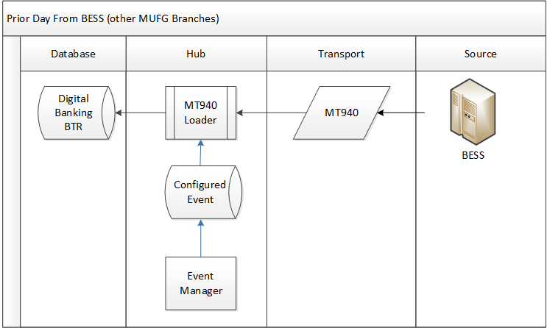

## Load Alerts

|  |  |  |  |  |  |  |
| --- | --- | --- | --- | --- | --- | --- |
| Business Purpose | Interface System | Message Format | Transport | Intermediary | IDT Configuration Required | HLD Required |
| Send Alerts Generated from Hub Load Events | CMB | restFul (JSON) | MQ | EIP | Yes | No |
| Received Send Acknowledgements | CMB | restFul (JSON) | MQ | EIP | Yes | No |

## Send RTP Payment (Payment Release) (RTP)

|  |  |  |  |  |  |  |
| --- | --- | --- | --- | --- | --- | --- |
| Business Purpose | Interface System | Message Format | Transport | Intermediary | IDT Configuration Required | HLD Required |
| Releases Payment to Gateway Provider | Fiserv | ISO20022 (Pain) | MQ | MUFG | No | No |

## Receive RTP Confirmation (RTP)

|  |  |  |  |  |  |  |
| --- | --- | --- | --- | --- | --- | --- |
| Business Purpose | Interface System | Message Format | Transport | Intermediary | IDT Configuration Required | HLD Required |
| Load Response from Crediting Bank to Confirm RTP | Fiserv | ISO20022 (pacs) | MQ | MUFG | No | No |

## Receive RTP Acknowledgement (RTP)

|  |  |  |  |  |  |  |
| --- | --- | --- | --- | --- | --- | --- |
| Business Purpose | Interface System | Message Format | Transport | Intermediary | IDT Configuration Required | HLD Required |
| Load Acknowledgment generated by receiving customer | Fiserv | ISO20022 (camt) | MQ | MUFG | No | No |

## Receive Request for Information (RTP)

|  |  |  |  |  |  |  |
| --- | --- | --- | --- | --- | --- | --- |
| Business Purpose | Interface System | Message Format | Transport | Intermediary | IDT Configuration Required | HLD Required |
| Load Request for Information message associated to a RTP | Fiserv | ISO20022 (camt) | MQ | MUFG | No | No |

## Respond to Request for Information (RTP)

|  |  |  |  |  |  |  |
| --- | --- | --- | --- | --- | --- | --- |
| Business Purpose | Interface System | Message Format | Transport | Intermediary | IDT Configuration Required | HLD Required |
| Send Information Response | Fiserv | ISO20022 (camt) | MQ | MUFG | No | No |

## Confirmation that Response was received (RTP)

|  |  |  |  |  |  |  |
| --- | --- | --- | --- | --- | --- | --- |
| Business Purpose | Interface System | Message Format | Transport | Intermediary | IDT Configuration Required | HLD Required |
| Load Response Confirmation | Fiserv | ISO20022 (pacs) | MQ | MUFG | No | No |

## Receive Incoming RTP (RTP)

|  |  |  |  |  |  |  |
| --- | --- | --- | --- | --- | --- | --- |
| Business Purpose | Interface System | Message Format | Transport | Intermediary | IDT Configuration Required | HLD Required |
| Load RTP payment | Fiserv | ISO20022 (Pain) | MQ | MUFG | No | No |

## Send Request for Information (RTP)

|  |  |  |  |  |  |  |
| --- | --- | --- | --- | --- | --- | --- |
| Business Purpose | Interface System | Message Format | Transport | Intermediary | IDT Configuration Required | HLD Required |
| Release Request for Information | Fiserv | ISO20022 (camt) | MQ | MUFG | No | No |

## Receive Request for Information Response (RTP)

|  |  |  |  |  |  |  |
| --- | --- | --- | --- | --- | --- | --- |
| Business Purpose | Interface System | Message Format | Transport | Intermediary | IDT Configuration Required | HLD Required |
| Load Request for Information Response | Fiserv | ISO20022 (camt) | MQ | MUFG | No | No |

## Send Payment Acknowledgement (RTP)

|  |  |  |  |  |  |  |
| --- | --- | --- | --- | --- | --- | --- |
| Business Purpose | Interface System | Message Format | Transport | Intermediary | IDT Configuration Required | HLD Required |
| Release Payment Acknowledgement | Fiserv | ISO20022 (camt) | MQ | MUFG | No | No |

## Customer Migration Utilities

Bottomline will provide some scrubbed work product from prior ACI migrations. This will show how the SPML would be mapped from other ACI extracts. These maps will not take into consideration any ACI customizations, so hence there will need to be a detailed HLD to memorialize the mapping rules and business decisions.

The formats below are the formats that will be loaded by the DGB application. There will be an additional utility that will convert ACI specific extract formats into the conversion formats below. The format and mapping specifications (ACI to DGB) will be detailed in a separate document. BAI2 Historical data will be a direct feed to DGB and will not be covered by the utility.

## Customer Setup

|  |  |  |  |  |  |  |
| --- | --- | --- | --- | --- | --- | --- |
| Business Purpose | Interface System | Message Format | Transport | Intermediary | IDT Configuration Required | HLD Required |
| Migrate Customer Setup, Accounts, Users, and User Entitlements | Legacy | SPML | File | None | No | Yes |

## Wire Templates

|  |  |  |  |  |  |  |
| --- | --- | --- | --- | --- | --- | --- |
| Business Purpose | Interface System | Message Format | Transport | Intermediary | IDT Configuration Required | HLD Required |
| Migrate Wire Templates | Legacy | Proprietary | File | None | No | No |

## ACH Templates

|  |  |  |  |  |  |  |
| --- | --- | --- | --- | --- | --- | --- |
| Business Purpose | Interface System | Message Format | Transport | Intermediary | IDT Configuration Required | HLD Required |
| Migrate ACH Templates | Legacy | Proprietary | File | None | No | No |

## Import Maps

|  |  |  |  |  |  |  |
| --- | --- | --- | --- | --- | --- | --- |
| Business Purpose | Interface System | Message Format | Transport | Intermediary | IDT Configuration Required | HLD Required |
| Migrate Customer Setup, Users, and User Entitlements |  |  |  |  |  |  |

## Scheduled Payments

|  |  |  |  |  |  |  |
| --- | --- | --- | --- | --- | --- | --- |
| Business Purpose | Interface System | Message Format | Transport | Intermediary | IDT Configuration Required | HLD Required |
| Migrate Wire Templates |  |  |  |  |  |  |

## Historical Balance and Transactions

|  |  |  |  |  |  |  |
| --- | --- | --- | --- | --- | --- | --- |
| Business Purpose | Interface System | Message Format | Transport | Intermediary | IDT Configuration Required | HLD Required |
| Load Multiple days of prior day BAI |  | BAI2 | File | None | No | No |

We will likely have to get a snap-shot of the active accounts at the time of conversion so that the appropriate set of accounts can be loaded to support the historical needs based on the current list.

This was mentioned as a preference to pre-loading as we go since the list of accounts could increase to a different set at go-live

## Transfer Templates

|  |  |  |  |  |  |  |
| --- | --- | --- | --- | --- | --- | --- |
| Business Purpose | Interface System | Message Format | Transport | Intermediary | IDT Configuration Required | HLD Required |
| Migrate Transfer Templates | Legacy | Proprietary | File | None | No | No |

## Customer Import/Export Functions

## Quick Books Export Web Connect

|  |  |  |  |  |  |  |
| --- | --- | --- | --- | --- | --- | --- |
| Business Purpose | Interface System | Message Format | Transport | Intermediary | IDT Configuration Required | HLD Required |
| Load Quick Books with Cash Reporting Data | Quick Books | Intuit Proprietary | HTTPS | None | No | No |

## Quicken Export Web Connect

|  |  |  |  |  |  |  |
| --- | --- | --- | --- | --- | --- | --- |
| Business Purpose | Interface System | Message Format | Transport | Intermediary | IDT Configuration Required | HLD Required |
| Load Quicken with Cash Reporting Data | Quick Books | Intuit Proprietary | HTTPS | None | No | No |

## Quick Books Export Direct Connect

|  |  |  |  |  |  |  |
| --- | --- | --- | --- | --- | --- | --- |
| Business Purpose | Interface System | Message Format | Transport | Intermediary | IDT Configuration Required | HLD Required |
| Load Quick Books with Cash Reporting Data | Quick Books | Intuit Proprietary | HTTPS | None | No | No |

## Quicken Export Direct Connect

|  |  |  |  |  |  |  |
| --- | --- | --- | --- | --- | --- | --- |
| Business Purpose | Interface System | Message Format | Transport | Intermediary | IDT Configuration Required | HLD Required |
| Load Quicken with Cash Reporting Data | Quicken | Intuit Proprietary | HTTPS | None | No | No |

## BAI Export

|  |  |  |  |  |  |  |
| --- | --- | --- | --- | --- | --- | --- |
| Business Purpose | Interface System | Message Format | Transport | Intermediary | IDT Configuration Required | HLD Required |
| Provide BAI file of Cash Reporting Data to Customer | Browser | BAI2 | HTTPS | None | No | No |

## CSV Export

|  |  |  |  |  |  |  |
| --- | --- | --- | --- | --- | --- | --- |
| Business Purpose | Interface System | Message Format | Transport | Intermediary | IDT Configuration Required | HLD Required |
| Provide CSV Cash Reporting Data to Customer | Browser | Proprietary CSV | HTTPS | None | No | No |

## SWIFT MT94xx Export

|  |  |  |  |  |  |  |
| --- | --- | --- | --- | --- | --- | --- |
| Business Purpose | Interface System | Message Format | Transport | Intermediary | IDT Configuration Required | HLD Required |
| Provide MT9xx Cash Reporting Data to Customer | Browser | SWIFT MT9xx | HTTPS | None | No | No |

## NACHA Import

|  |  |  |  |  |  |  |
| --- | --- | --- | --- | --- | --- | --- |
| Business Purpose | Interface System | Message Format | Transport | Intermediary | IDT Configuration Required | HLD Required |
| Import ACH Payments in NACHA format | Browser | NACHA | HTTPS | None | No | No |

## NACHA Pass-through

|  |  |  |  |  |  |  |
| --- | --- | --- | --- | --- | --- | --- |
| Business Purpose | Interface System | Message Format | Transport | Intermediary | IDT Configuration Required | HLD Required |
| Import NACHA File to be passed in-tact to Back Office | Browser | NACHA | HTTPS | None | No | No |

## Wire Import

|  |  |  |  |  |  |  |
| --- | --- | --- | --- | --- | --- | --- |
| Business Purpose | Interface System | Message Format | Transport | Intermediary | IDT Configuration Required | HLD Required |
| Import Wire Payment Instructions | Browser | Proprietary CSV | HTTPS | None | No | No |

## Detail Import

|  |  |  |  |  |  |  |
| --- | --- | --- | --- | --- | --- | --- |
| Business Purpose | Interface System | Message Format | Transport | Intermediary | IDT Configuration Required | HLD Required |
| Import Payments in Client-defined format | Browser | Client Defined | HTTPS | None | No | No |

## MT101 Formatted Payment Import

|  |  |  |  |  |  |  |
| --- | --- | --- | --- | --- | --- | --- |
| Business Purpose | Interface System | Message Format | Transport | Intermediary | IDT Configuration Required | HLD Required |
| Import Payment Instructions in MT101 Format | Browser | MT101 | HTTPS | None | No | No |

## CSV Multi-Type Payment Import

|  |  |  |  |  |  |  |
| --- | --- | --- | --- | --- | --- | --- |
| Business Purpose | Interface System | Message Format | Transport | Intermediary | IDT Configuration Required | HLD Required |
| Import multiple payment types in CSV format | Browser | Proprietary CSV | HTTPS | None | No | No |

## ISO20022 Payment Import

|  |  |  |  |  |  |  |
| --- | --- | --- | --- | --- | --- | --- |
| Business Purpose | Interface System | Message Format | Transport | Intermediary | IDT Configuration Required | HLD Required |
| Import Payment Instructions in ISO20022 format | Browser | ISO20022 $PAIN.001 | HTTPS | None | No | No |

## Check Issuance Import

|  |  |  |  |  |  |  |
| --- | --- | --- | --- | --- | --- | --- |
| Business Purpose | Interface System | Message Format | Transport | Intermediary | IDT Configuration Required | HLD Required |
| Import Check Issuance and Voids | Browser | Proprietary | HTTPS | None | No | No |

## Services to Support Mobile (P3)

MUFG intends to develop and manage their own mobile application using the Digital Banking RESTful service calls to access required functionality. These RESTful services are session-aware and access Digital Banking respecting the user’s defined access rights.

## Mobile Functionality

|  |  |  |  |
| --- | --- | --- | --- |
| Functional Group | Function | Service | Comments |
| Information Reporting | Access Prior Day and Current Day Account Information | Inquiry Service |  |
|  | Access Filter Criteria Data | Inquiry Service |  |
|  | Get Check Image | Image Inquiry Service |  |
| Payments | Payment Inquiry | Inquiry Service |  |
|  | Access Filter Criteria Data | Inquiry Service |  |
|  | Wire and ACH Batch Approval | Approval Service |  |
|  | Initiate Wire from Template | Create Payment |  |
|  | Initiate ACH from Template | Create Payment |  |
|  | Template Inquiry | Inquiry Service |  |
|  | Template Approval | Approval Service |  |
| Transfers | Transfer Inquiry | Inquiry Service |  |
|  | Access Filter Criteria Data | Inquiry Service |  |
|  | Access Debit and Credit Accounts | Inquiry Service |  |
|  | Approve Transfer | Approval Service |  |
|  | Initiate Transfer (free form) | Create Transfer |  |
| Check Management | Check Inquiry | Inquiry Service |  |
|  | Access Filter Criteria Data | Inquiry Service |  |
|  | Create Stop (single or range) | Create Stop |  |
|  | Cancel Stop | Cancel Stop |  |
| Risk Management | Exception Inquiry | Inquiry Service |  |
|  | Access Filter Criteria Data | Inquiry Service |  |
|  | Decision Exception | Update Exception |  |
|  | Create Check Issuance | Create Issuance | Get definition around term “upload them to the bank” |
| Legacy Reports | View Available Reports | Inquiry Service |  |
|  | Access Filter Criteria Data | Inquiry Service |  |
|  | Returns, Large Dollar Early Warnings, Dispositions |  | Need to understand Requirements |
|  |  |  |  |
| Admin Functions | User Inquiry | User Service |  |
|  | Access Filter Criteria | User Service |  |
|  | Approve User | User Service |  |
|  | Role Inquiry | User Service |  |
|  | Role Approval | User Service |  |

## Services to Support Anti-Fraud (approach TBD)

Web ACH will use Guardian Analytics – DGB will send a copy of all NACHA files to MUFG who will then forward it to Guardian Analytics and Pep+. The fact that there is a fraud solution for ACH in the midst, is transparent to Digital Banking.

For Avalon 2 (Branch) Digital Banking-initiated Wires may use Digital Banking Secure Payments for providing fraud scoring. The plan right now is to use Actimize for the Avalon 3 (Combined Bank and Branch).

**Implementation Options:**

1. Digital Banking Secure Payments for All payment types, where Digital Banking does the Fraud Score request, Fraud Scoring, and Interdiction.
2. Digital Banking uses Secure Payments for branch destination wires, but uses existing Actimize/Back-office hold mechanism where Digital Banking sends fire and forget asynchronous messages for bank destination wires.
3. Digital Banking performs Fraud Score requests to Actimize and performs interdiction based on the fraud score returned from Actimize.

Any of the above options are available and can be configured by payment type and bank branch code.

## Synchronized Fraud Score Request and Response

## Asynchronous Fraud Score Request

In Avalon 3, there will be asynchronous fraud scores coming out from Digital Banking to bank-bound wires. These fraud scores will go out from Digital Banking as part of the submit, modify, approval workflows. Actimize is slated to perform the interdiction directly with the Wire system.

The fraud scoring and interdiction for the branch-bound wires will remain in the Digital Banking Secure Payments solutions.

## Update Payment based on Asynchronous Fraud Score

# Portal Integrations and SSO

**SSOA**

SSOA is the back office application used at MUFG. SSOA will integrate with Digital Banking using SAML2 SSO.

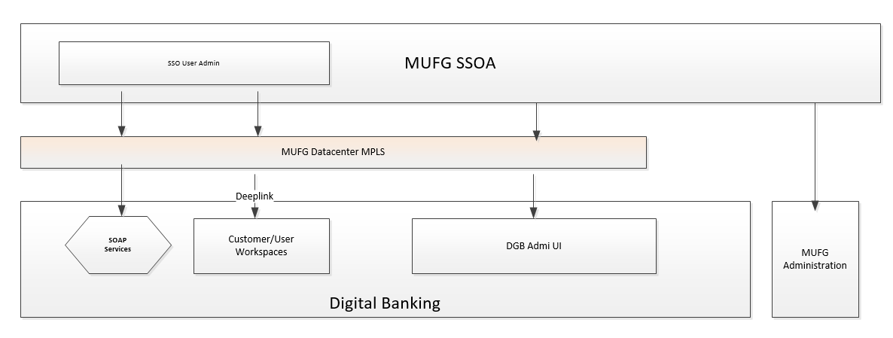

Customer and User Administration will be initiated via SSOA UI and pushed down to digital banking via web service calls. Note that only the shell data model (with all fields that are to be synced up with SSOA) will we created vai the Web Service call. The rest of the setup including entitlements, settings, accounts, limits, Ach companies etc. will be setup using the DGB UI.

DGB will be accessed via Customer and User Deep Links while performing user and customer admiration on the SSOA UI. Or by launching the entire Bank Admin application in a separate tab for all other administration tasks/back office support activities.

Note the entire DGB back office application/associated services and simulation will be accessed via the Private MPLS line

**Interaction**

|  |  |  |  |
| --- | --- | --- | --- |
| SSOA Customer/User sync | Web service calls | SOAP/HTTPS  (SSO Id passed in payload) | Private line (MUFG datacenter - MPLS) |
| SSOA Customer/User direct link | Deep Link (Customer, User context) | HTTPS (SAML2 SSO SP initiated SSO – Shibboleth active mode/ui-admin, /ui-admin-portal) | Private line (MUFG datacenter - MPLS) |
| SSOA Administration | Full Admin UI | HTTPS (SAML2 SSO SP initiated SSO – Shibboleth active mode /ui-admin, ui-admin-portal) | Private line (MUFG datacenter - MPLS) |
| Simulation | /ui (Client application) | HTTPS (token cookie SSO – Shibboleth passive mode /ui) | Private line (MUFG datacenter - MPLS) |

**SSO/Financial Center**

Financial Center is the Portal application used at MUFG. Financial Center will integrate with Digital Banking using SAML2 SSO. MUFG SSO which is integrated with Financial Center is the User Administration site at MUFG.

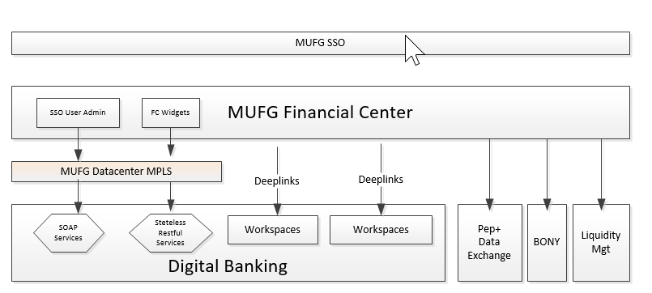

User Administration will be initiated via MUFG SSO UI and pushed down to digital banking via web service calls. Note that only the shell data model (with all fields that are to be synced up with SSO) will we created vai the Web Service call. The rest of the setup including entitlements will be setup using the DGB Client UI.

DGB will be accessed via User Deep Links while performing user and customer admiration on the MUFG SSO UI. SSO will Deep Link into DGB UI (User Context) for User Administration access.

Financial Center will access DGB via Contextual Deep links from the Mega Menu. The dashboard /landing page will have widgets hosted by MUFG. Financial Center Widgets will have supporting API’s hosted at MUFG’s data center – any data required from DGB will be made directly form the data center via the private MPLS line. No stateless Restful service call will be made to DGB either via the browser or over the internet – all stateless interaction will be initiated from MUFG’s data center over the private MPLS network.

Only the direct Deep link and Deep linked Client UI service (state-ful) calls will be made over the internet.

**Interaction**

|  |  |  |  |
| --- | --- | --- | --- |
| SSO User Sync | Web service calls | SOAP/HTTPS  (SSO Id passed in payload) | Private line (MUFG datacenter - MPLS) |
| Financial Center direct link vain mega menu | Deep Link (contextual) | HTTPS (SAML2 SSO SP initiated SSO – Shibboleth active mode  /ui-portal) | Internet (Public) |
| Financial Center dashboard widget services | Stateless Restful calls | HTTPS (user SSOID passed in the http header) | Private line (MUFG datacenter - MPLS) |

It is anticipated that as part of the bank and client admin application, the RSA token management function will be utilized. Below is a high-level summary diagram of that product function.

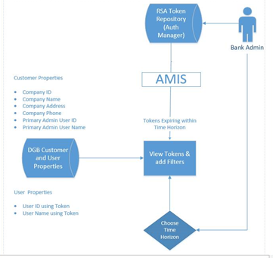

# SSO/Financial Center Service Requests (SOAP)

|  |  |  |
| --- | --- | --- |
| Interface ID | Interface Description | Bottomline WSDL/Operation |
| WCA-DTB-1025/WCA-DTB-1036(Comp API) | SSO Create Customer | UserGroupMaintServic/createUserGroup |
| WCA-DTB-1028 | SSO Edit Customer, mainly customer name and customer ID | UserGroupMaintService/updateUserGroup |
| WCA-DTB-1029 | SSO Delete Customer | UserGroupMaintService/deleteUserGroup |
| WCA-DTB-1031 | SSO Customer Status/Get Customer Details | UserGroupMaintService/getUserGroupDetail |
| WCA-DTB-1034 | SSO Reactivate/Restore Customer | UserGroupMaintService/restoreUserGroup |
| WCA-DTB-1021 | SSO Edit User | UserMaintService/updateUser |
| WCA-DTB-1022 | SSO User self service | UserSelfService/changeUserSettings |
| WCA-DTB-1023/WCA-DTB-1035(Comp API) | SSO Create User | UserMaintService/createUser |
| WCA-DTB-1024 | SSO Delete User | UserMaintService/deleteUser |
| WCA-DTB-1026 | SSO User Status SSO Check User Exist | UserMaintService/userDetail |
| WCA-DTB-1027 | SSO User List Summary Details | UserMaintService/getUserList |
| WCA-DTB-1033 | SSO Reactivate User | UserMaintService/restoreUser |

# Financial Center Service Requests (RestFul)

**Mega menu/Quick links**

1. /banking-services/api/workspaces/getAllDeeplinks  (mega menu)

Action Items

1. /banking-services/api/notifications/getNotifications  (action widget)

**Favorite Template**

1. /banking-services/api/inquiry/getQueryResults ( favorite template)

**Balance:**

1. /banking-services/api/balanceAndTransaction/depositAccounts/PRIORDAY/accountSummary/getListView (balance—individual accounts)
2. /banking-services/api/balanceAndTransaction/depositAccounts/CURRDAY/accountSummary/getListView (balance—individual accounts)
3. /banking-services/api/balanceAndTransaction/depositAccounts/PRIORDAY/accountSummary/getAcctGroupTotalsList (balance – account group)
4. /banking-services/api/balanceAndTransaction/depositAccounts/PRIORDAY/accountSummary/getAcctGroupBalanceSummary (balance – account group drill down)

**Search widget:**

1. /banking-services/api/tableMaintenance/getLookupResults  (Search widget – get transaction types)
2. /banking-services/api/balanceAndTransaction/depositAccounts/previousDay/getSearchTransactions/getListView  (Search widget – past payments)
3. /banking-services/api/payment/listView/corp/getListView  (Search widget – pending payments)

**Approval widget:**

1. /banking-services/api/payment/listView/corp/getListView (approval widget -- get pending payments)
2. /banking-services/api/payment/listView/corp/approve (approval widget – approve payment)
3. /banking-services/api/payment/listView/corp/delete
4. /banking-services/api/payment/listView/corp/reject
5. /banking-services/api/mfaService/getSettings (approval widget – getSettings)
6. /banking-services/api/mfaService/validate (approval widget – validate token)

# Extended Functionality

# Advanced Configurations

|  |  |  |  |  |  |
| --- | --- | --- | --- | --- | --- |
| **Ref #** | **Category** | **Description** | **Priority** | **In Current System** | **Configuration** |
| 1 | RESTful Service | Ability for Liquidity Management application to initiate wires and multi-bank payments | High | Yes |  |
| 2 | NACHA Recon Report Extract | Every time a NACHA extract takes place, a Reconciliation report will be created and sent via file transfer. There will be one file produced for each NACHA file produced to either bank or branch. | High | Yes | A format will need to be defined for this report. |

# Payment Automation

# Solution Overview

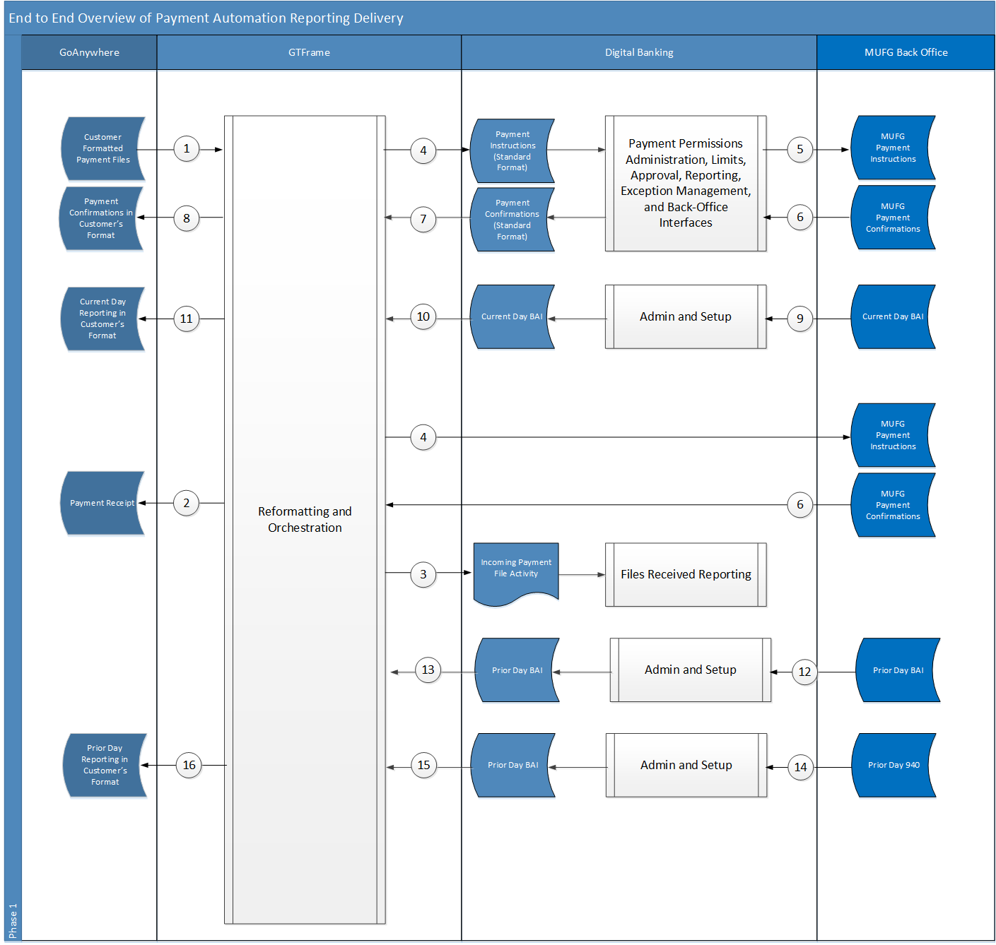

1. Files arrive via GoAnywhere in the client’s designated format, and are passed to GTFrame.
2. If the file is in the correct format, and there is a defined Payment Acknowledgment Receipt Format, then GTFrame creates that file and sends it back to the SFTP Customer Gateway.
3. A GTFrame summarizing what was in the incoming payment file memorializes the event in Digital Banking
4. GTFrame reformats the payment file to either Digital Banking or the MUFG back-office in the standard format accepted by those systems.
5. Approved Payments in Digital Banking are sent to the MUFG back-office using the existing Digital Banking host interfaces.
6. Where applicable, the MUFG back office will send payment confirmation messages to the system from which they received the payment instructions.
7. Payment confirmations will be forwarded to GTFrame for those customers who have a format which has a confirmation file defined.
8. GTFrame reformats the payment confirmations into the format required by that customer.
9. Current Day BAI files are sent to Digital Banking.
10. Digital Banking sends client-specific BAI files to GTFrame to be reformatted into the client desired format at the bank-designated times.
11. GTFrame sends the current day details in the format the customer requires.
12. Prior Day BAI files are loaded into Digital Banking
13. When the BAI load completes, Digital Banking will send BAI files to GTFrame for each of the Payment Automation User IDs
14. Prior Day MT940 messages are sent and loaded into Digital Banking
15. When the MT940 load completes for a specific account, a single account BAI file will be sent to GTFrame for each of the Payment Automation User IDs who have access to that account.
16. When receiving the end of day BAI file from DGB for a Payments Automation User, GTFrame will format it into the format associated with the User ID.

# In-Scope Payment Automation Formats

# Payment Files

|  |  |  |  |
| --- | --- | --- | --- |
| Format | Description | Payment Types | New for MUFG or Existing |
| EDIW | EDI for Wires Only | All Wire Payments | Existing |
| MTEDI | EDI Multi-Type | Wires, Transfers, ACH, External | Dec 18 |
| NACHA | NACHA | All ACH | Existing |
| Zenith | Proprietary XML | ACH, Wires, Transfers | Existing |
| Datafaction | Proprietary XML | ACH, Wires, Transfers | Existing |
| MTCSV | Bottomline Proprietary CSV | ACH, Wires, Transfers, External[1] | Dec 18 |
| MTFW | Bottomline Proprietary FW | ACH, Wires, Transfers, External | Dec 18 |
| MTISO | ISO20022 | ACH, Wires, Transfers, External | Dec 18 |
| MTIDOC | SAP Proprietary | TBD | New |
| MTMCSV | MUFG Proprietary CSV | ACH, Wires, Transfers, External | New |
| MTMFW | MUFG Proprietary FW | ACH, Wires, Transfers, External | New |

# Reporting Files

|  |  |  |  |
| --- | --- | --- | --- |
| Format | Description | Contents | New for MUFG or Existing |
| BAI | BAI File Current Day | Balances and Transactions | Existing Current Day |
| BAI | BAI Prior Day | Balances and Transactions | New[2] |
|  |  |  |  |
|  |  |  |  |
|  |  |  |  |
|  |  |  |  |
|  |  |  |  |

1. Payment Types that are not handled by Digital Banking can be mapped directly to a file format required by another bank system.
2. Trigger mechanism must be developed to invoke Digital Banking BAI export when load completes for a given data source.